DT: 4/26/18 3:45PM – Sent to Janet for approval



Southern California Edison
CS Re-Platform Project

CIM-CS-07 - Handle Bill Inquiries
Customer Interaction Management
Business Process Design
Version Final 1.3

Table of Contents
1 Business Process Overview 5
Current Pain Points for Southern California Edison 5
Responsible Parties 5
Document Control 6
Terminology 6
2 Business Process Design 8
Handle Bill Inquiry Details 8
Billing Overview and Bill Images 8
Rate Comparison and Analysis 10
User Utility Tax (UUT) 11
Bill Adjustments 11
Service Orders 12
E-Bill 12
Collective/ Joint Invoicing 15
Budget Billing Plan 15
Meter Readings 15
Dunning & Payment Lock 16
Billing Block 17
Process Energy Advice Requests 18
Activities, Ticket and BPEM Cases 19
2.1.1 List of Tickets 22
2.1.2 List of BPEM cases 23
Process / Performance Improvement 23
Prerequisites and Inputs 23
General Assumptions 24
Business Process Hierarchy 24
Process Flows 24
2.1.3 Handle Bill Inquiry – E-Bill 24
2.1.4 Handle Bill Inquiry 26
3rd Party and SCE Legacy System Integrations 29
Data Elements 29
2.1.5 Business Partner Search (Basic) 29
2.1.6 Business Partner Search (Advanced) 30
2.1.7 Search Contract Account 30
2.1.8 Search Premise 31
2.1.9 Billing Overview and Bill Image 32
2.1.10 View E-Bill via FOP 33
Cloud for Customer (C4C) Integration 34
2.1.12 Processes 34
2.1.13 Hybris C4C Views 34
2.1.14 Activities 35
Exception Management Requirements 35
Process Risks and Mitigation 36
Key Performance Indicators 36
2.1.15 Key Metric Definition 36
3 Controls, Regulatory Rules, and Security 37
Security Considerations 37
Custom Program/Transaction Codes 37
Custom Table/Transaction Codes 38
Data Criticality and Cybersecurity Baseline Risks 38
4 Technical Considerations 40
4.1 RICEF-W Assessment 40
4.1.1 Reports 40
4.1.2 Interfaces 40
4.1.3 Conversion 40
4.1.4 Extension/Enhancements 41
4.1.5 Forms 42
4.1.6 Workflows 42
4.2 IDEX Considerations 42
4.3 Production System Cut-over Considerations 42
4.4 Other Considerations 42
5 Change Management 43
5.1 Change Impacts 43
6 Requirements 50
7 Tickets 51
7. Appendix 52

This page intentionally left blank

Business Process Overview
The Handle Bill Inquiry process defines how to manage a variety of questions from a Business Partner (BP) regarding their bill, which will be done via Hybris C4C. These topics can range from general billing questions to E-Bill requests or Energy Advice Requests. If the inquiry is resolved by the CCC or BCD representative during the call with the BP, an Activity will be manually created by the CCC or BCD representative to document the call and no further action is required. However, if the inquiry is not resolved by the CCC or BCD representative, an Activity will be created stating such and a ticket or a BPEM case will be created and routed to the appropriate workgroup for further handling.

Current Pain Points for Southern California Edison
- General Bill Inquiries
  - There are times when the BI Rep needs to forward the BI to additional depts. for further research.
  - Not all agents are able to address bill inquiries from customers, in some cases BI’s are being created when perhaps they could be resolved with the first call.
  - No visibility to the status of Billing Inquiry
- E-Bill
  - Not a consistent approach across all channels when offering Paperless billing when the customer has already declined.
  - Customer does not have access to historical bills in online following registration in Paperless Billing (only subsequent bills will appear). Results in call into the call center and confusion why they don’t have access to their data.
  - Separate Customer Accounts for Deposit and Energy results in an incomplete view of the charges to the customer on their paperless bill which includes only Energy charges.
  - Auto enrolling / defaulting customers to Paperless Billing when they make an online payment is resulting in calls into the call center / complaints
  - Paperless bills on My Account can only be associated to one user.
  - From the CCC, agents are not viewing the bill in the same format making referencing the bill with the customer over the phone difficult.

Responsible Parties
Contact | Contact Person
Southern California Edison Business Process Owner | Janet Covington
Southern California Edison Lead | Christine Evans
HCL Functional Lead | Adrianus Halim
Solution Architect | Pedro Costa
Front Office Lead | Christine Evans
Subject Matter Experts | Deborah Tillman  Scott Hirth
Key User Group | CCC, BCD, RSO

Document Control
Version | Description of Change | Date | Author
0.1 | Creation of Initial Version | 01/08/2018 | Jessica Marsillo
0.2 | Review | 03/01/2018 | Tuan Howe Yap
0.3 | Update | 03/08/2018 | Jessica M / Tuan Y
0.4 | Update based on Adrian review | 03/11/2018 | Tuan Howe Yap
0.5 | Review and update | 03/11/2018 | Jessica Marsillo
0.6 | Update based on Pedro review | 03/12/2018 | Jessica M/ Tuan Yap
0.7 | Updated Visio | 03/13/2018 | Jessica Marsillo
0.8 | Update based on CSRP review | 03/15/2018 | Tuan Howe Yap
0.9 | Update based on Cari review | 03/19/2018 | Tuan Howe Yap
0.10 | Updated based on Cari review | 03/20/2018 | Tuan Howe Yap
0.11 | Update based on business review | 03/22/2018 | Tuan Howe Yap
Final v1.0 | Process Owner approved version | 04/25/2018 | Tuan Howe Yap
Final v1.1 | Update based on SCC 260 | 07/13/2018 | Tuan Howe yap
Final v1.2 | Update BPD with latest business process | 11/21/2019 | Tuan Howe Yap
Final v1.3 | Update after Cari review | 12/04/2019 | Tuan Howe Yap

Terminology
Term/Acronym | Definition and SAP Equivalent (if applicable)
APSE | Accelerated (or Axon) Project Support Environment
BDEX | SAP add-on functionality to support the processing of BPEM Cases
Billing Cycle | Is a group of contracts to be billed together via date-driven or regional criteria, it controls the billing cycle and is linked to the Meter Reading Unit. SAP equivalent term is the Portion.
Billing Document | A document that outlines the charges incurred for energy consumption for a specific contract. During the process of Billing, a billing document is generated for each contract on a contract account.
BP Contact | This can also be called as Customer Contact in S/4HANA acting as an interaction log to record activities related to a customer
BMD | Business Master Data. The customer information which includes personal details, payment terms, dunning levels, billing rates and rate categories. The business master data objects are Business Partner, Contract Account and Contract.
BWR | Basic Work Request. SAP equivalent is BPEM.
CA | Contract Account
Channel | Data object in SAP that holds the interval data. Intervals can be kwh, price, factor, etc. SAP equivalent is Profile.
Clarification | A list of payments that could not be processed and require additional work in order to be posted.
Connection Object | Link between installation and postal regional structure. Usually a building, but can also be a piece of property or other facility, such as a fountain or construction site. The connection object corresponds to the functional location in plant maintenance (PM).
Customer | Any entity with a relationship with SCE. This term is usually used in reference to customers (both individuals and organizations) This can include employees and third party suppliers (banks and payment partners). SAP Equivalent is Business Partner (BP)
BPD | Business Process Design (or Document)
BPEM | Business Process Exception Management
EAM | SAP Enterprise Asset Management
Hybris C4C | SAP Cloud for Customer Solution
IMG | SAP Implementation Guide - where configuration is performed
Level Pay Plans | SAP equivalent term is Budget Billing. Budget Billing allows customers to pay regular equal amounts over a yearly period.
S/4HANA | SAP HANA 4 Business Suite
SCE | Southern California Edison
Summary Billing | Standard SAP functionality that enables the invoicing of multiple Contract Accounts under one Parent Contract Account (Consolidated Summary Billing). SAP equivalent is Collective Billing.
TMD | SAP Technical Master Data e.g. Connection Object, Premise and Device Location
Additional terms may be found in APSE General Document # 32 CSRP Glossary

Business Process Design
User will always authenticate and validate that the requestor is an authorized user before providing account information or carry out transaction for the requestor.

Handle Bill Inquiry Details
A BP may contact a CCC or BCD representative with a variety of questions regarding their bill, which can be answered using various screens in both Hybris C4C and S/4HANA.

Billing Overview and Bill Images
The Billing Overview Screen in Hybris C4C provides a single view of the billing/invoice history of the Business Partner, including 36 months of billing history. Here, the CCC or BCD Representative can find the invoice date, amount due, date open amount, payments received, and whether or not a bill reversal has occurred (Figure 1: Billing Overview).

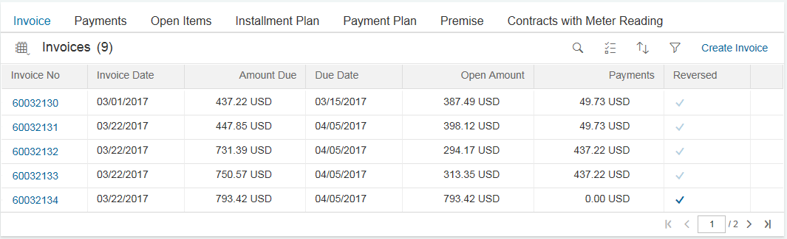
Figure 1: Billing Overview

From the Billing Overview Screen in Hybris C4C, the CCC or BCD Representative can access the associated Bill Images by clicking on the Invoice Number hyperlink (Figure 2: Bill Image). Using the Bill Image, the CCC or BCD representative can view and compare bills in multiple sessions within Hybris C4C with the following. Alternatively, user can navigate to Consolidated Bill view mentioned on the next page or view the PDF bill and find the following details:
- Bill Period
- Amount Due
- KWH
- KW
- KVAR
- Usage by Consumption Period (On Peak, Off Peak, etc.)
- Period Days
- Credit and debits based on demand response event participation, regulatory adjustment (i.e. climate credit, ERRA), rebates or miscellaneous adjustments
- NEM Settlement Bills (used to review monthly information)
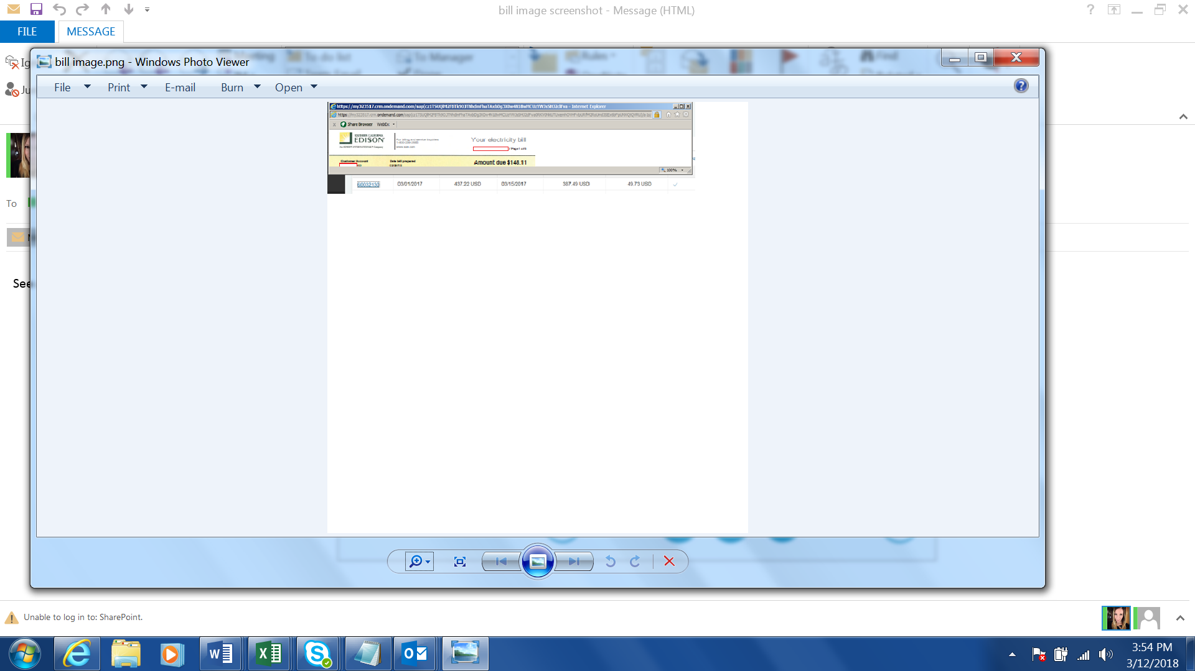
Figure 2: Bill Image

Using Hybris C4C, the CCC or BCD Representative can view the PDF bills by clicking on the Invoice number hyperlink in the Invoices section (Figure 3: View PDF bill).

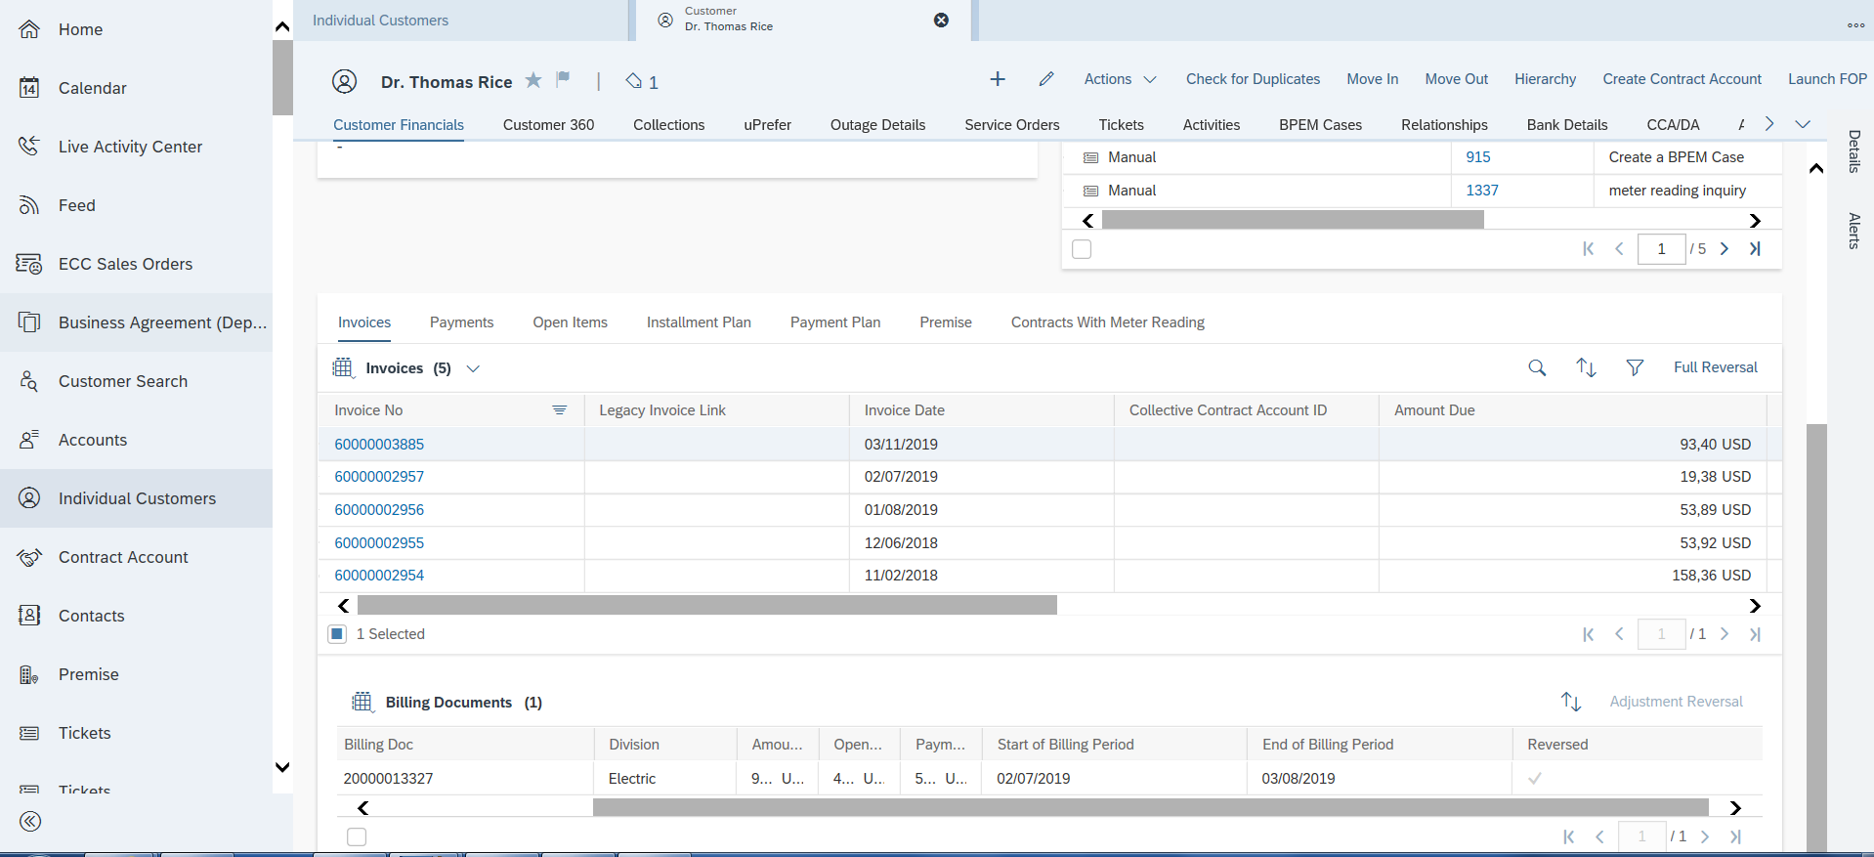
Figure 3: View PDF bill

To view whether a contract is NEM (Net Energy Metering), VNM (Virtual Net Metering), MASH, etc., the CCC or BCD Representative should view the Installation Facts via Hybris C4C Billing Parameters section (Figure 4: Billing Parameters). Representative can use the filter to select the type of Installation Facts that he/she wanted to see. Or navigate to the Contract Account FOP to view the NEM Billing Data.
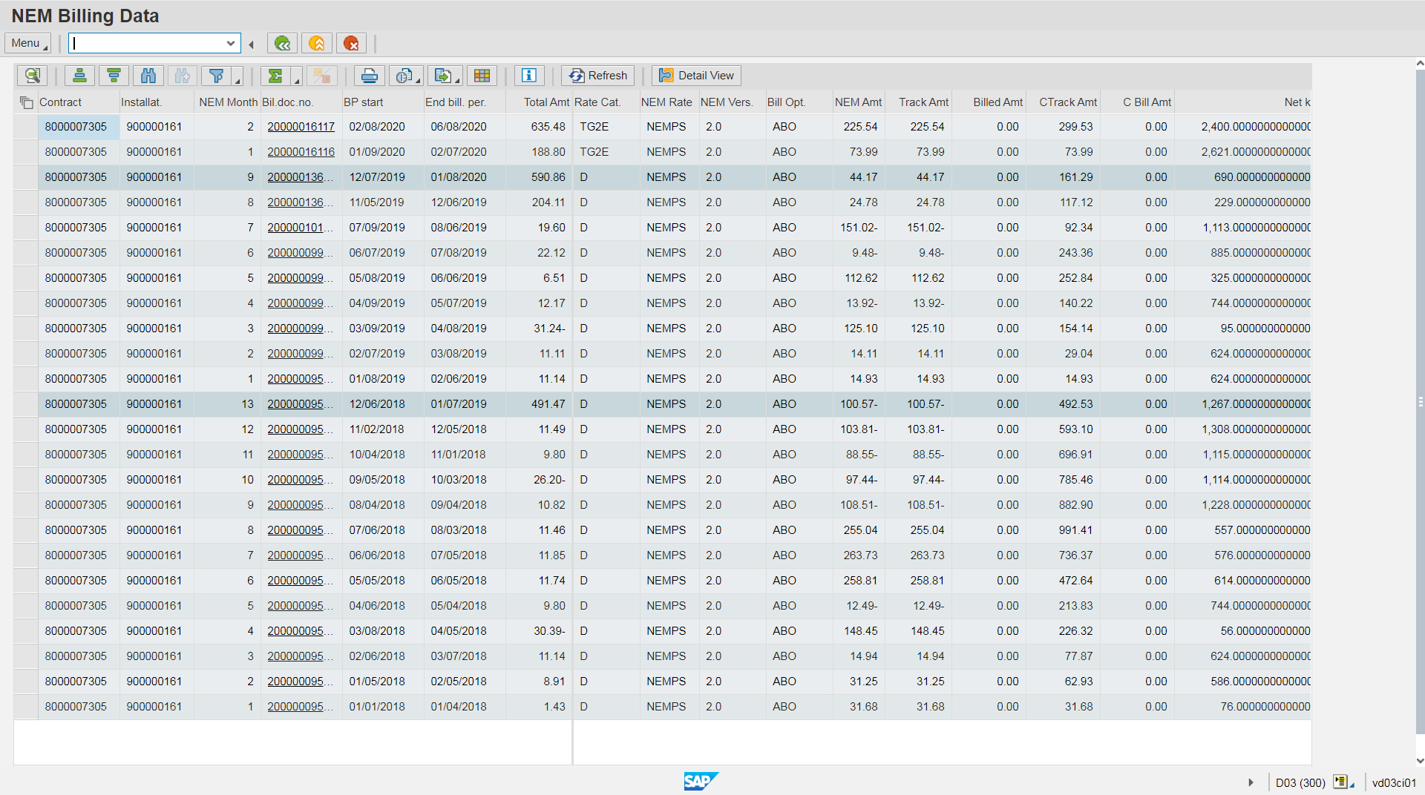

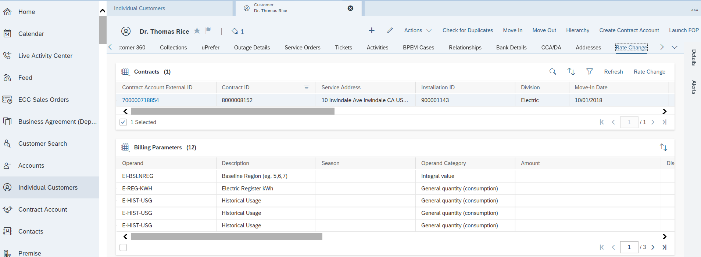
Figure 4: Billing Parameters

Installation Facts is also used to host other data, such as Usage data, Billing History, Program & Product etc. This information will be available in the Billing Parameters view in Hybris C4C.

Duplicate Bill
If a Business Partner (BP) requests a duplicate bill to be sent to them based on their preferred communication method, a CCC or BCD representative can do so via C4C Customer Financials facet Invoices tab Select the Invoice # hyperlink. A PDF document will be shown on the screen and user can print the bill on the local printer or email to customer manually. User can also refer the Business Partner (BP) to sce.com to reprint the statement(s).


Consolidated Bill View
BP may request a summary of past meter reading and billing history while on the phone with user, user will navigate to a Hybris C4C Contract Account FOP NEM Billing Data (tcode ZCon_Bill_View) to view the information in Consolidated Bill View (Figure 5: Consolidated Bill view). By using this view, user does not need to open up multiple bill images to obtain the information. This view contains the followings information:

  - KWH
  - KW
  - Billing Days
  - Total KWH Usage
  - Avg kWh Usage per day
  - Daily Cost
  - Bill Amount
This customized screen will be made available in S/4HANA for optimization purpose and will be done using enhancement E-CIM-CS-17 - Consolidated Bill View.
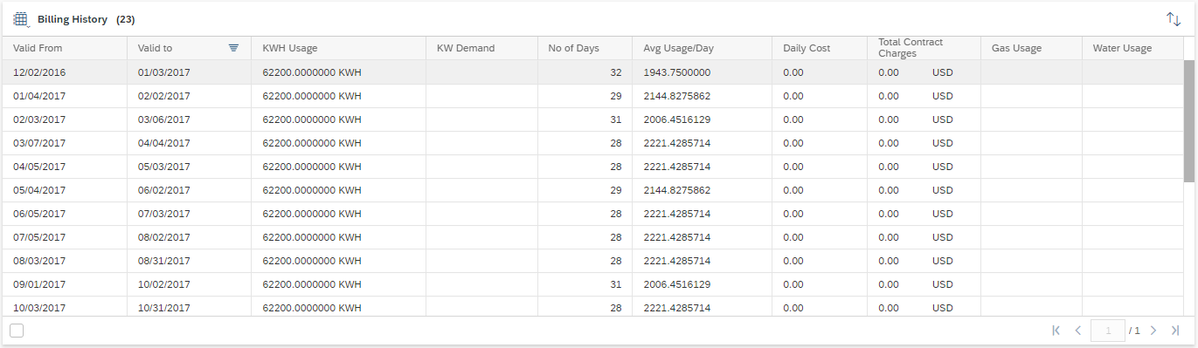

Figure 5: Consolidated Bill view

NEM Inquiry
Customer may call with questions related to their NEM bill. To provide information to customer, user will navigate to OpenText xECM (Enterprise Content Management) to view the NEM bill image or in Hybris C4C navigate to the invoice view and click on the hyperlink of the invoice number. Refer to BPD CIM-CS-09 Handle Inbound Request for more information.
To identify an existing or previous customer who was enrolled in NEM, user would navigate to C4C Billing Parameter facet. Installation Facts will contain NEM item. Refer to BPD document UB-BI-12 Calculate Energy Bill - Net Metering for additional information such as automatic creation of BPEM case

Rate Comparison and Analysis

A CCC or BCD representative can complete a rate analysis via SCE.COM by entering Contract number and postal code. Super users will be able to view rate analysis with more advanced features in GridX outside of SAP. The GridX will then be launched and the CCC/BCD representative can log in using their assigned username. If the CCC or BCD representative is unable to obtain the rate analysis via SCE.COM or GridX, they will create a Ticket with the category ‘Rate Analysis Request’. The Ticket should be routed to the CCC Offline Support to or BCD Rate Analysis COE depending on the customer type.

User Utility Tax (UUT)
UUT is a tax that is imposed by certain cities for electric service. To view if the contract is subject to UUT, CCC or BCD representative will navigate to Installation screen (tcode ES32) via FOP in Hybris C4C. Entry populated in Franchise Contract indicates contract has UUT (Figure 6: Franchise Contract). If the value needs to be changed, the user will create a BPEM case via FOP. RSO will attend to the BPEM Case and update the value accordingly.
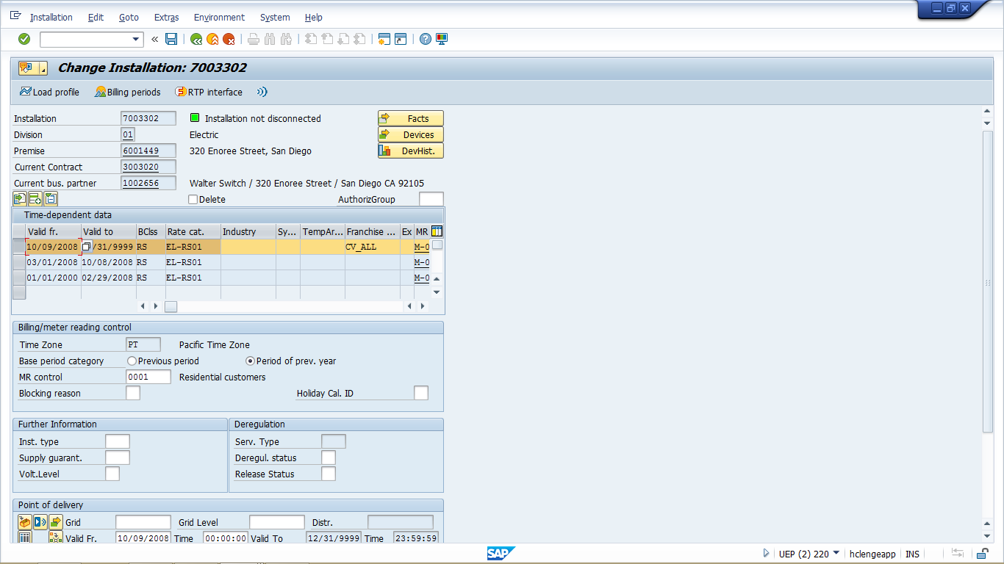

Figure 6: Franchise Contract

Should a Business Partner (BP) request UUT exemption, the representative can create a BPEM using category “UUT exemption”. If customer refuses to pay the UUT charges, the system will not be disconnected due to non payment. The representative can create a BPEM using category “UUT Refused to Pay”. These BPEM cases go to RSO Billing.

Bill Adjustments/Reversal/Rebill
If a front office employee believes a bill correction needs to be completed, the C4C user will create a Ticket to the CCC BI team. The BI Team will confirm if a reversal/rebill/correction to bill is needed. If the meter is a mechanical (Register) meter, the BI Team will complete the reversal and correct usage as needed. If the meter is an IDR meter, the BI team will create a BPEM case with the category ‘Bill Correction’, to RSO Billing. All other C4C users who believe a bill correction needs to be completed by back office will create a BPEM case with the category ‘Bill Correction’, to RSO Billing.

The Full Reversal, Adjustment Reversal and Create Invoice buttons in Hybris C4C will be hidden.

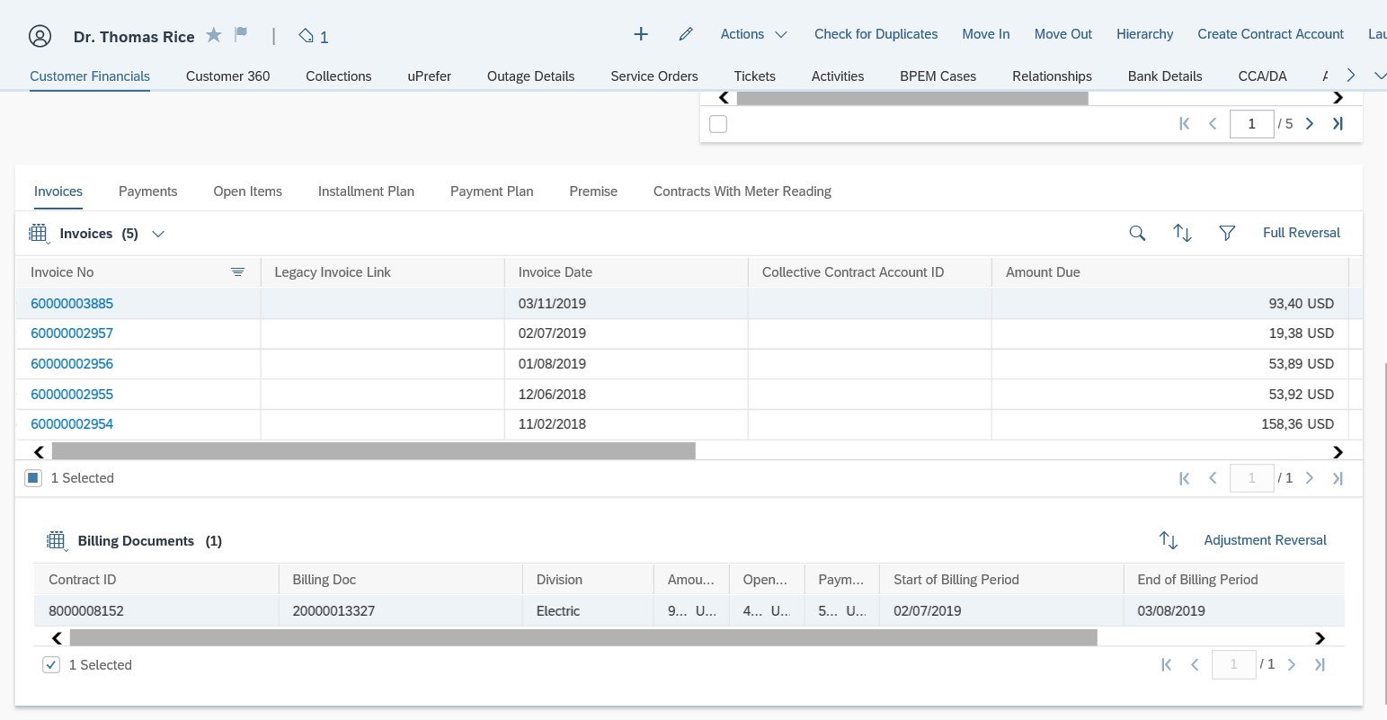
Figure 7: Bill Adjustment

Service Orders
When necessary, the CCC or BCD representative will be able to create a Service Order to resolve a Business Partner’s inquiry through Hybris C4C Service Order facet. Refer to BPD CIM-CS-05 - Handle Request - Process Field Work Request for more information.

E-Bill
E-Bill allows a BP to receive their bills electronically. The BP will receive an email notification from SCE containing the hyperlink that directs them to SCE.com when an electronic copy of their bill is ready. Up to 20 months of billing will be available for viewing on SCE.com at the time of SAP go-live.

A CCC or BCD representative can view the BP’s enrollment in E-Bill via S/4 on the Contract Account screen (tcode CAA3) or in Hybris C4C via Customer Financials Contract Account Details hyperlink Overview tab Additional Information section Corr Control field.

The representative can view if the BP was enrolled in E-Bill (example: CheckFree, SCE.com or IVR) by viewing the BP Contact from C4C Utility 360 facet Recent History Customer Contact section (Figure 7: BP Contact in C4C). If the user manually enroll BP in E-Bill, an Activity will be created by the user manually. Refer to BPD CIM-CS-12 for more information on Activity.

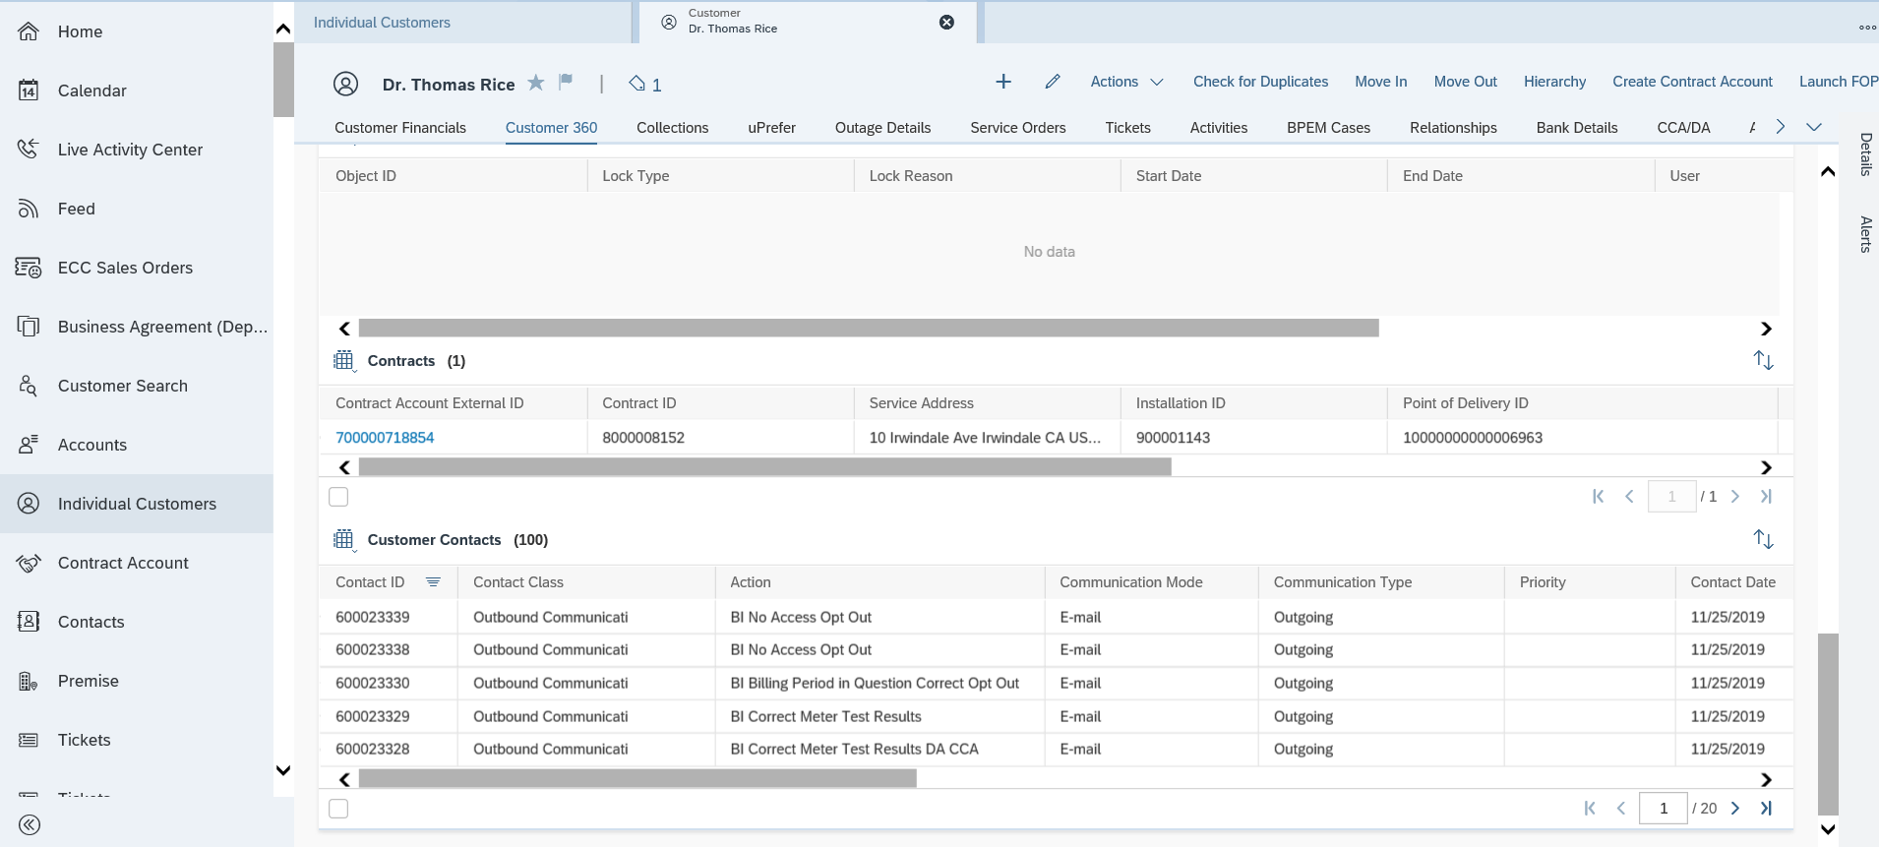

Figure 7: BP Contact in C4C

Enrollment
Requests to enroll in E-Bill are received by phone, SCE.com, IVR, marketing campaign, online payment default, credit card (applicable for residential customers with MyAccount) or third-party (Check Free). Refer to BPD CIM-CS-10: Manage Customer Self-Service for more information about E-Bill enrollment and MyAccount.

It is possible for multiple BPs to receive the same bill for a Contract Account.

Once a BP agrees to enroll in E-Bill, the CCC or BCD representative will use FETCH (if needed) to read the Terms and Conditions of E-Bill to the BP. The CCC or BCD representative will then manually create an Activity to capture the acceptance of the Terms and Conditions by the BP.

De-enrollment from E-Bill
Requests to de-enroll in E-Bill are received by phone, e-mail, in person, CheckFree, SCE.com and IVR. A CCC or BCD representative can de-enroll a BP’s contract account(s) in E-Bill using the Contract Account FOP, Update Corresp Control (Ebill) from Hybris C4C. There will be no changes to the de-enrollment process via SCE.com or IVR.

Once the de-enrollment process is complete, the CCC or BCD representative will create an Activity in Hybris C4C manually to capture the reason for de-enrollment from E-Bill.

Collective/ Joint Invoicing
Collective and Joint Invoicing is also known as Summary Billing in legacy CSS. When a BP requests Collective Invoicing or wishes to modify their Collective accounts, user will create a BPEM Case Category ‘Collective Billing Request/Inquiry’. BPEM case for Collective Billing is document in BPD CIM-CS-02 - Handle Customer Move-in/Out - Contract New. For Collective Invoicing, the child accounts must be manually linked to the master Contract Account by the back-office.
For Joint Invoicing, the representative will carry out the joint invoicing during Move In process in C4C . Refer to BPD UB-BI-10: Produce Invoice - Collective and Joint Invoicing for steps in setting up Collective and Joint Invoicing.

Budget Billing Plan
Budget Billing Plan is also known as Level Payment Plan in legacy CSS. The CCC or BCD representative will create a Budget Billing Plan when the BP requests to pay their annual bill amount in a fixed bill amount across a 12 month period. The representative will use the ‘Create Payment Plan’ function in Hybris C4C Customer Financials facet Payment Plan tab to create the Budget Billing Plan (Figure 8: Budget Billing Plan). To enroll a BP on Budget Billing Plan, customer has to meet eligibility requirement defined. Refer to BPD UB-BI-11: Manage Billing Arrangements - Payment Plan for more information about the Budget Billing Plan.

If needed, the user will be able to create a Ticket category ‘Budget Billing Plan’ to Offline Line Support or the BCD COE to setup or modify Budget Billing for a BP.

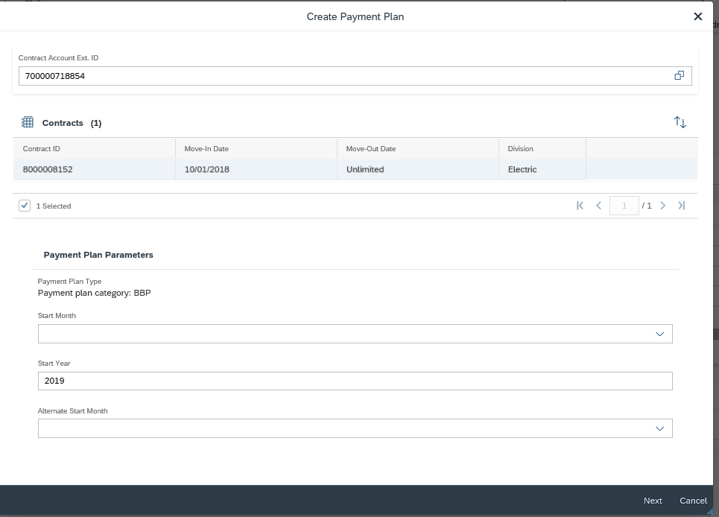
Figure8: Budget Billing Plan

Meter Readings
A Business Partner (BP) may inquire about meter readings, such as questions about estimates and actual meter readings.
- If meter is a non-smart meter or also known as Register Meter, the representative will navigate to Hybris C4C Meter Reading view. (Figure 9: C4C Meter Reading). Meter readings for the 50 thousand non smart meters will be available here.
- If the meter is a smart meter, the billing determinants for 4.5 million meters will be available via external application ITRON.
- If the representative requires the back office to correct a meter reading or obtain meter reading information, they will create a BPEM case via BP FOP BDEX transaction with the category ‘Bill Correction’, which will be routed to RSO Billing.

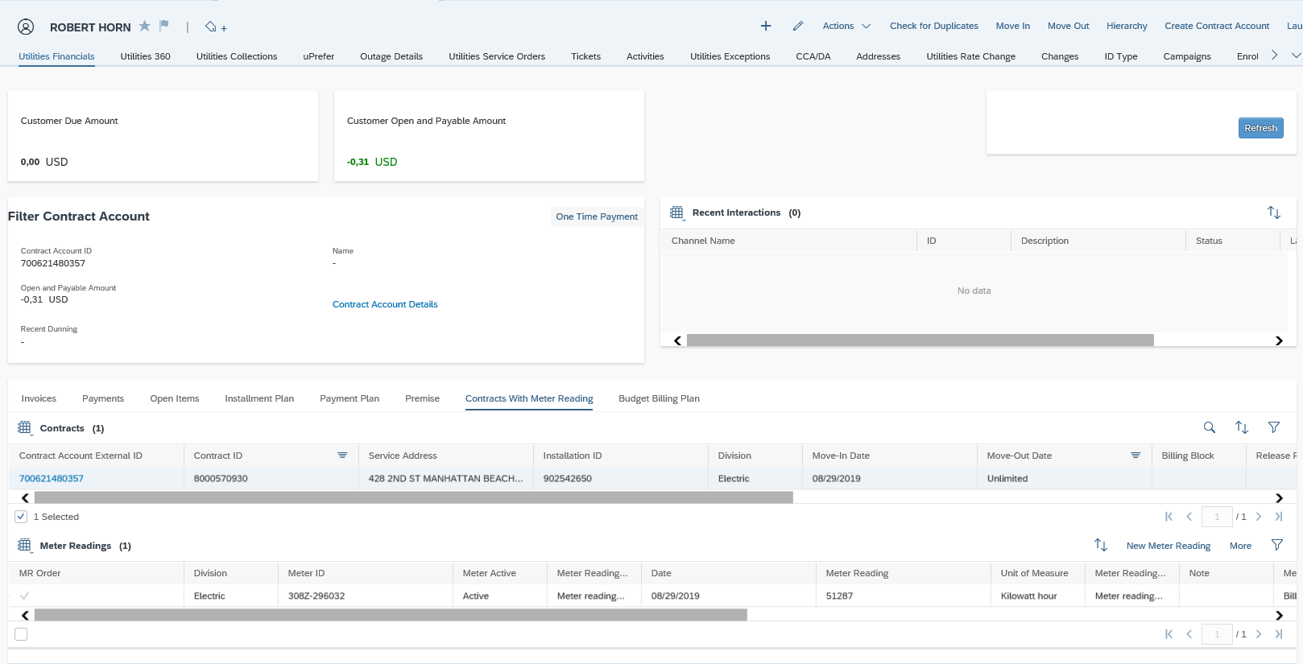
Figure9: C4C Meter Reading

Dunning & Payment Lock
Should a BP choose to dispute a bill, a Dunning Lock can be used to hold the amount of the bill being disputed with a start date and end date. By placing a Dunning Lock, the BP will be excluded from Collections (Dunning). Furthermore, a CCC or BCD representative may place an Incoming Payment Lock in Hybris C4C Open Item view to put a hold on any Direct Payments that may occur during the bill investigation with a start date and an end date (Figure 10: Create Dunning/Payment Lock). The creation of Dunning Lock and Incoming Payment Locks in both S/4HANA and Hybris C4C will be covered in the BPD CC-FI-04: Manage Collections (Dunning) - Manage Credit and Collections. The user should also add an Activity record on the BP indicating why the Dunning Lock or Incoming Payment lock was placed on the account.

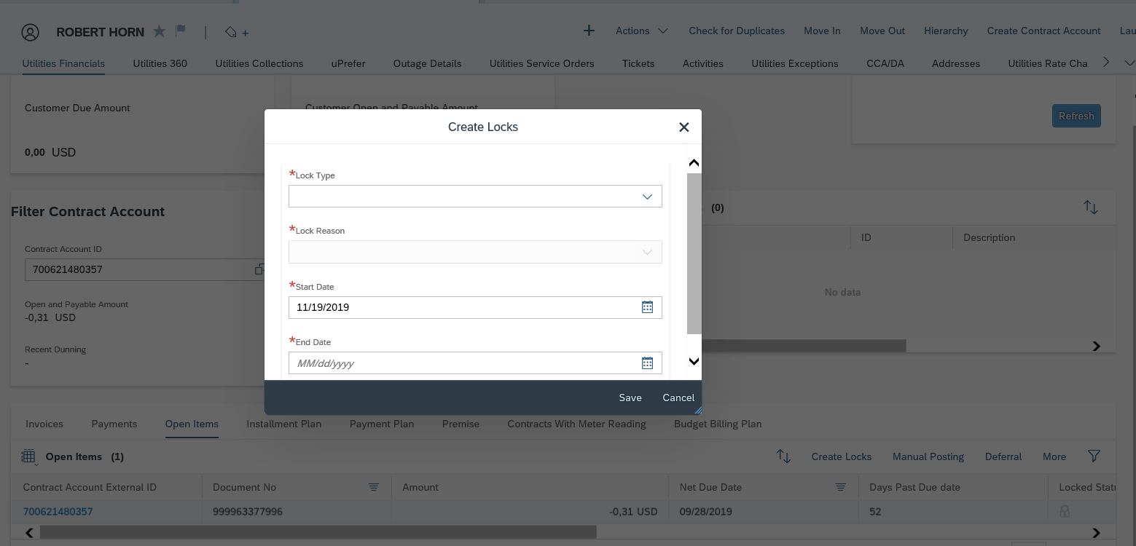
Figure 10: Create Dunning/Payment Lock

Billing Block
Billing Lock (also referred to as Billing Blocks in S/4HANA) is set on the Contract when the Contract is created and further investigation such as Credit Check returns a warning message or Same Party In is identified during Move In process. Billing Lock can be set to the Contract via Hybris C4C Utility 360 facet Details side panel option (Figure 11: Create Billing Lock).

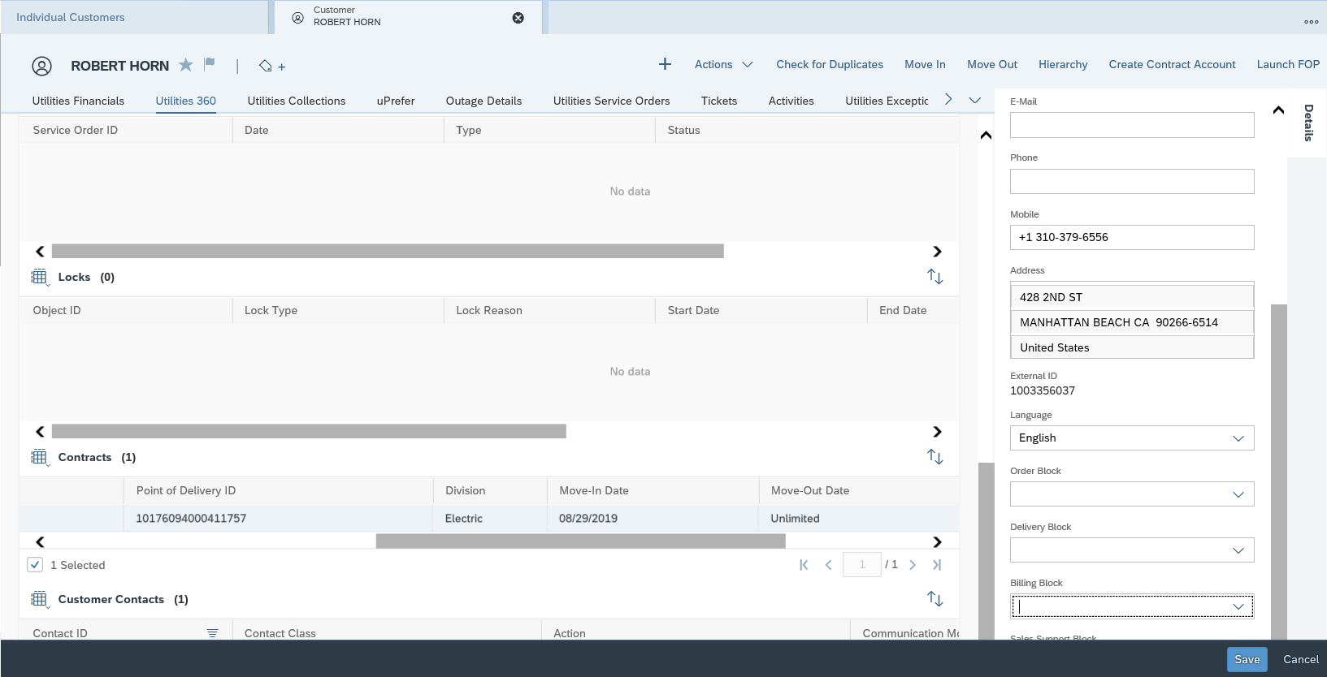
Figure11: Create Billing Lock

Invoice Lock
An Invoice Lock is set at the Contract Account (Figure 12: create Invoice Lock) when all of the Contracts for the entire Contract Account need to stop the invoice from being created. User will create the Invoice Lock via C4C Customer Financial Contract Account Details hyperlink Locks tab Create New Lock function. .

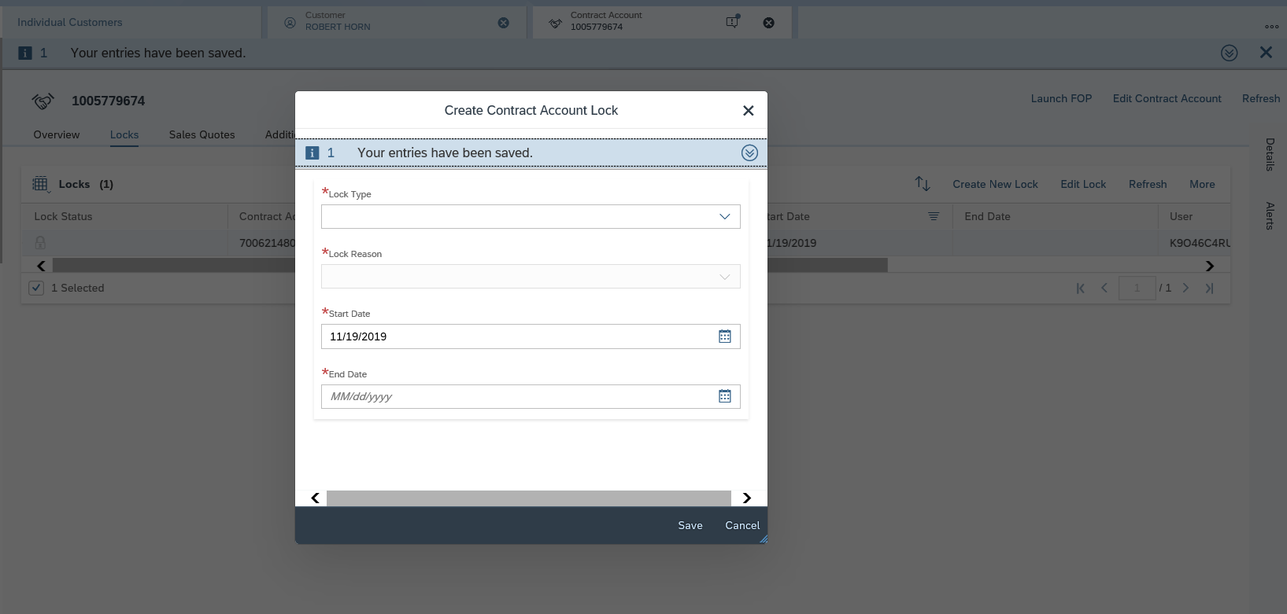
Figure12: Create Invoice Lock

Process Energy Advice Requests
A BP may request information or assistance to save energy and reduce their energy consumption and/or lower their bill. Requests of this nature can be made by phone, SCE.com, email, web chat, or postal mail. To complete the request, the CCC or BCD representative may simply provide the information the BP requires, or recommend a program to help reduce consumption. For more information about program eligibility and enrollment, refer to BPD PP-CS-01 Manage Program Strategy, Define & Manage Programs, Manage Catalog and PP-CS-02 (01 – 13) - Program Enrollment and Delivery, De-Enrollment & Decommission Programs. An Activity will be created manually by the CCC or BCD representative to document the handling of every request.

Sample Programs:
CARE/FERA
Low income Business Partners (BPs) eligible for the California Alternate Rates for Energy (CARE) program receive discount on their electric bill. The enrollment process for CARE/FERA will be covered in BPD CARE/FERA.

Demand Response Program Inquiries
Demand Response Program inquiries can include inquiries for Base-Interruptible Program (BIP), Critical Peak Pricing Program (CPP), Agricultural Pumping Interruptible (API), Summer Discount Program for residential and non-residential (SDP), Capacity Bidding Program (CBP), PTR, DLC, NetGen, Optional Binding Mandatory Curtailment (OBMC), SubTransmission, and Added Facilities. The enrollment process for Demand Response Programs will be covered in BPD Demand Response.

iEnergy
The representative can access iEnergy via C4C Quick Links on the home page when customer inquiries about information on their application and/or rebates.
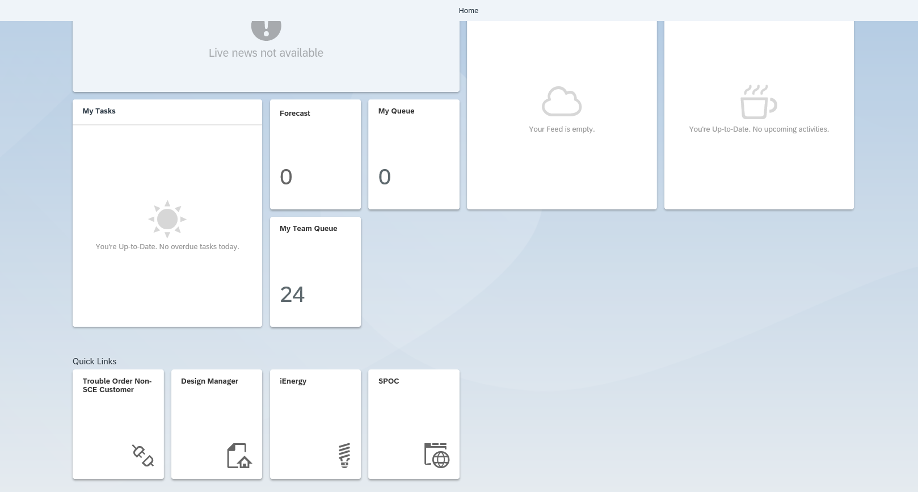

Activities, Ticket and BPEM Cases
Activity
This functionality replaces CSS notes, requested by and call disposition. The C4C user (e.g., CCC or BCD representative) will log an Activity after resolving the Business Partner (BPs) inquiry and can be used to document what was discussed even if additional follow-up is needed.

Ticket
If the C4C user (e.g., CCC or BCD representative) is unable to resolve the BP inquiry and if the issue needs to be sent to another Front Office group, a Ticket (Figure 13: Create Ticket) in Hybris C4C will have to be created manually. The user will select Ticket Category and select the name of the user or work group that will be working on the Ticket.

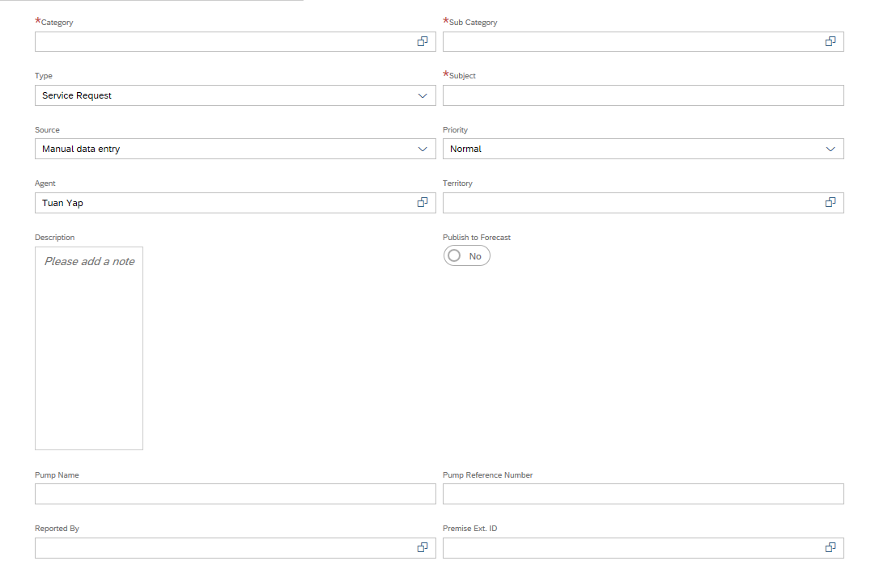
Figure13: Create Ticket

Depending on the status of the inquiry investigation, the representative that is working on the Ticket can update the Ticket status to ‘Work in Process’ or ‘Completed’ and document the resolution in the Ticket long text (Figure 14: Update Ticket). The statuses of a Ticket are Urgent, Intermediate, Normal and Low. Refer to BPD CIM-CS-06: Handle Customer Inquiries for more information on Ticket functionality.
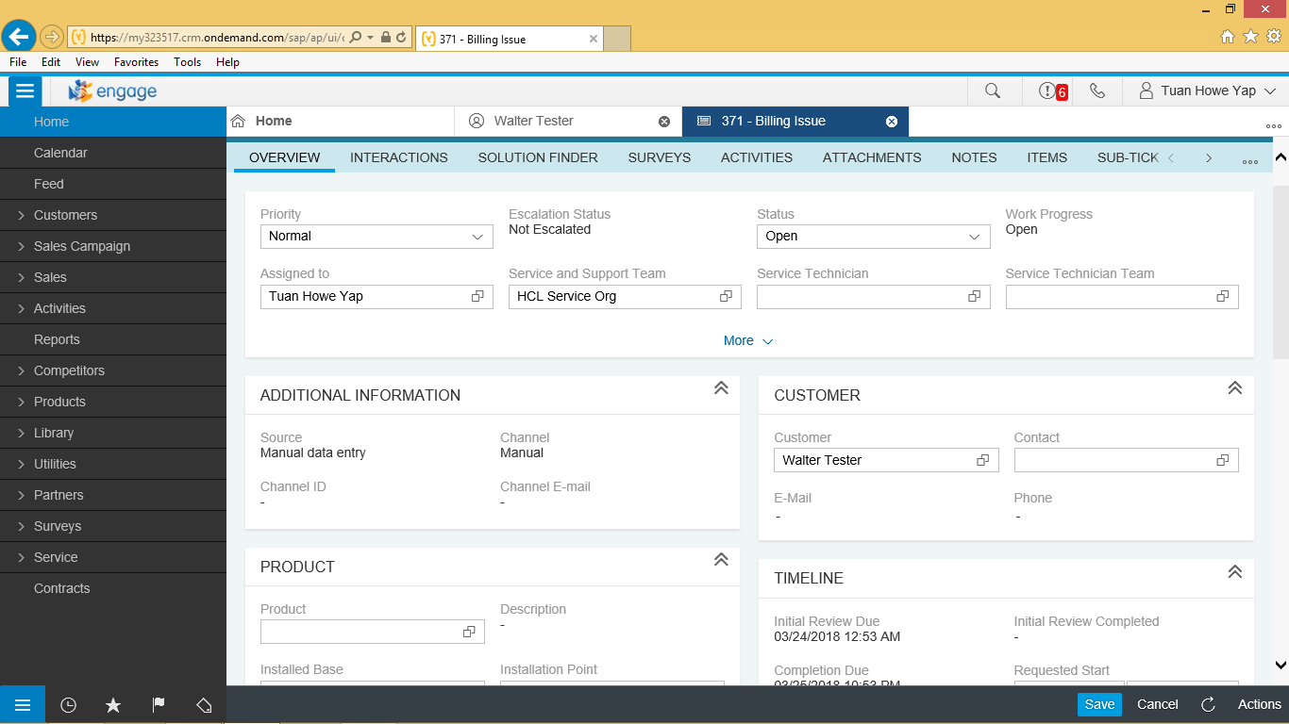

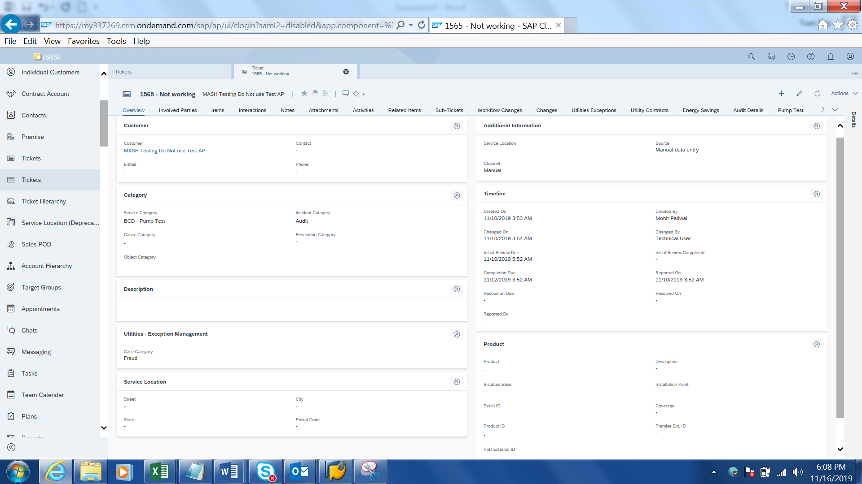
Figure14: Update Ticket

A report for Tickets is available in Hybris C4C (Figure 15: Ticket Hierarchy). Using this report, the user is able to see the list of tickets assigned to him/her, total list of ticket created in the system, tickets created last 7 to 365 days. These are standard Hybris C4C selections.
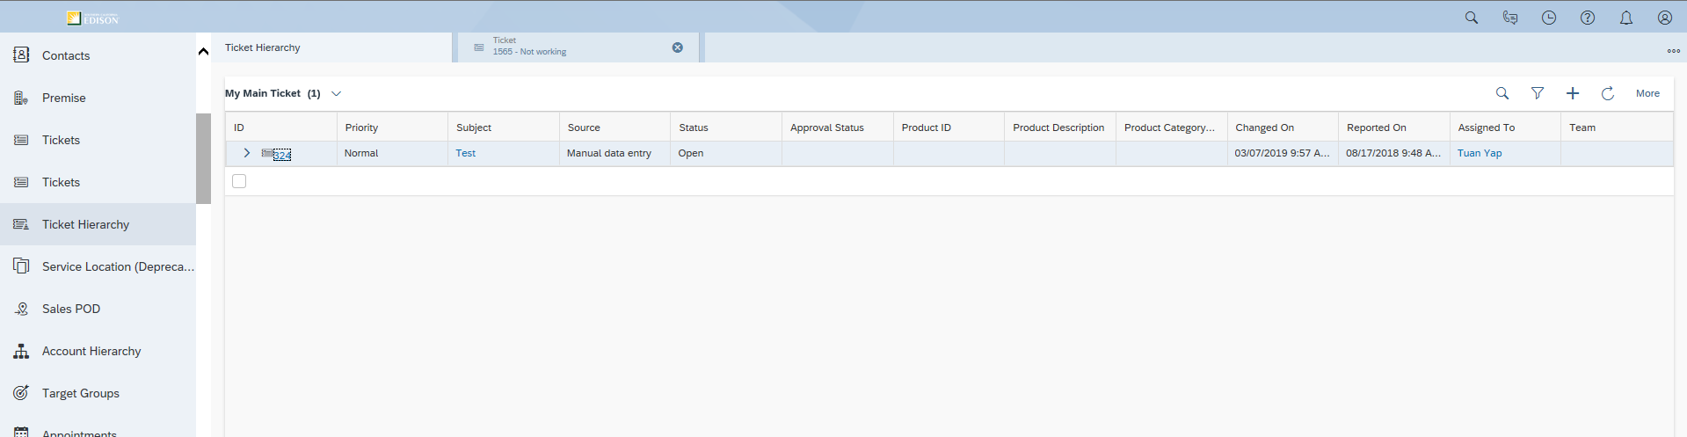
Figure15: Ticket Hierarchy

The report contains filters (Figure 16: Report for Tickets filters) that enables user to filter the list of Tickets based on the filters offered by Hybris C4C such as Assigned To, Status, Reported On, Ticket number, Priority etc..

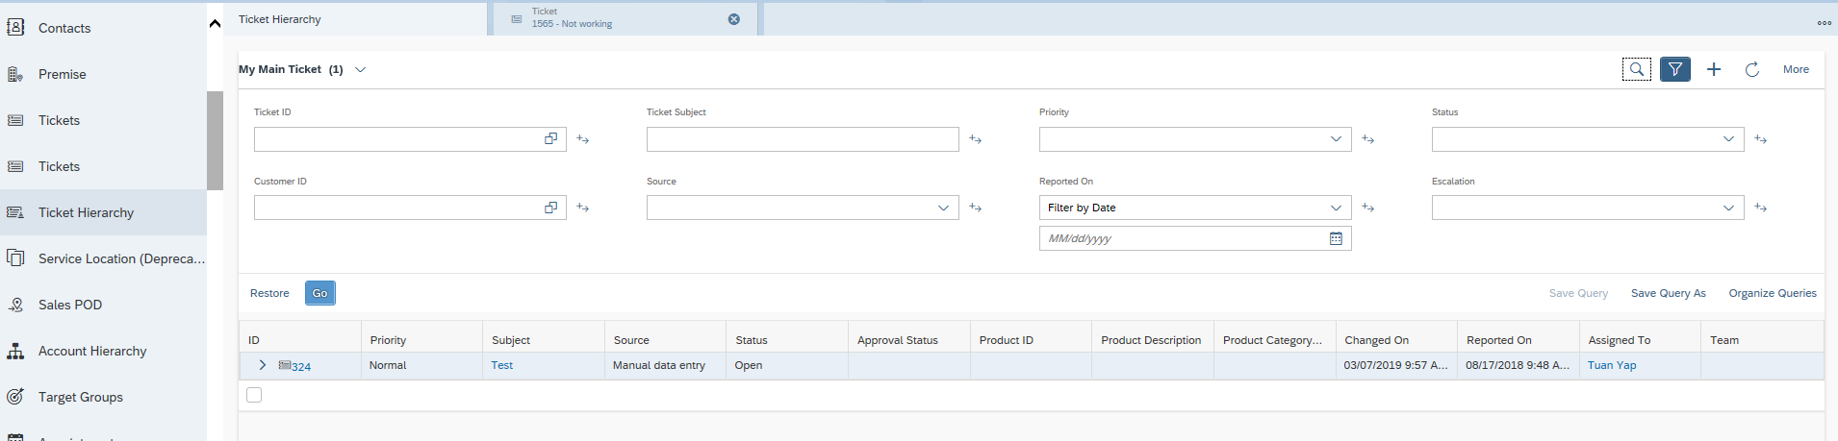
Figure16: Report for Tickets filters

BPEM
If a C4C user (e.g., CCC or BCD representative) is unable to resolve the BP inquiry and if the issue needs to be sent to someone In Back Office group (e.g., RSO, T&D), a BPEM case will be created manually in Hybris C4C BP FOP and routed to the appropriate back office workgroup for further handling. The user shall select BDEX Transaction to confirm a BPEM has not already been created prior to creating a BPEM. Upon creating the BPEM case, the user will also be able to select an appropriate category (Figure 17: BPEM Case Creation).

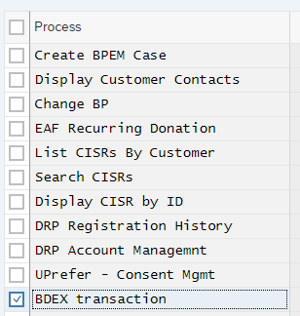
Figure17: BPEM Case Creation

BPEM Cases can then be further modified by the Back Office in BDEX/S/4HANA to capture the status, root cause, and results of the bill inquiry. Once they have been resolved, the BPEM Case status will be updated by the representative manually.

A summary report of BPEM Cases is available in S/4HANA by using T-Code /BTR/PP_ASTROLABE to run the report and T-Code /BTR/PP_SUM to display the report. User can also execute BDEX via C4C BP FOP to S/4 Tcode BTI/BDEX. This report provides information regarding BPEM Status for each type of BPEM (i.e. new, in process, completed), the number of BPEMs in each status, created date, and due date (Figure 18: BDEx Summary Report). To view more details for each BPEM case, the user can double click on the Key Number to open the case.

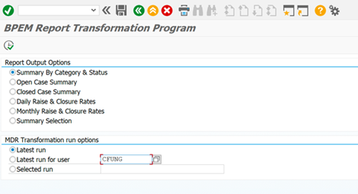

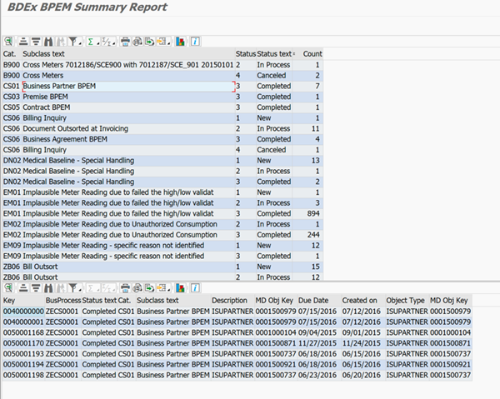
Figure18: BDEx Summary Report

List of Tickets
This section contains the list of tickets that results from Bill Inquiry. A Ticket is created by a Front Office user manually when an issue or request is unresolved and requires further investigation. Tickets can be routed to other C4C users (e.g., a person or a group within Front Office or a Front Office supervisor) manually. A ticket category is defined for a functional area and a ticket category could be used for various scenarios within that functional area. The various scenarios can be differentiated by the user providing the information in the Subject field in the Ticket. The Subject field accepts free form text (Figure 19: Ticket).

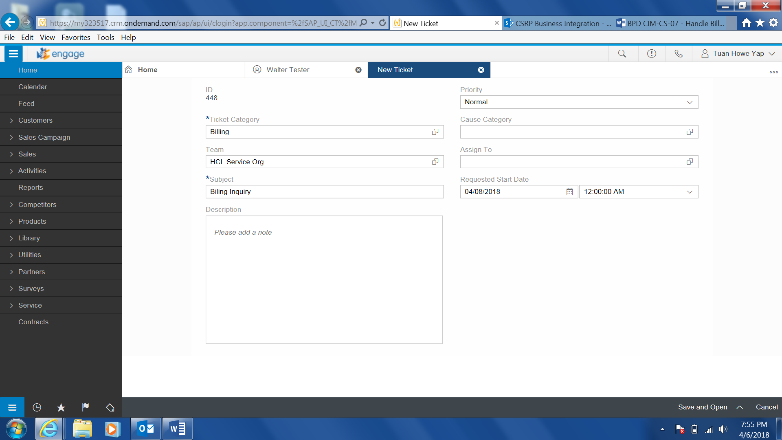
Figure19: Ticket

Refer to the attached document for a list of Ticket/ Category and responsible department/ person.

No. | Ticket Service Category/Sub Category | Subject Title | Department / Person
Refer to Ticket Worksheet.

List of BPEM cases
Refer to BPEM case worksheet.

Process / Performance Improvement
  - Activities, notes and events are centralized under the Business Partner
- Customer eventually has access to 36 months of historical bills as time goes after system go live

Prerequisites and Inputs
- Business Partner
- Contract Account
- Contract

General Assumptions
- The customer will have up to 12 months of billing history migrated
- There will be users within the CCC and BCD whom have access to the back office. If the action can’t be resolved by an agent, a BPEM will be issued to achieve resolution within the CCC/BCD before routing to RSO.
- If a C4C user (BI Team) cannot complete a customer inquiry, they will create an Activity and then BPEM to RSO billing.
- All pending Bill Inquiry will need to be extracted from CSS via IT query and manage an excel / Access database until closed or if the volume is low we will re-create them in C4C after go live. This is to mitigate the need for an enhancement to convert them into SAP.
- Extra BI support may be needed to complete as many BIs as possible just before go-live to minimize the effort to manually create open BIs after implementation.
- Change management will be completed with ENAs to ensure they are not sending BIs to the team that should be resolved by them or their lead to reduce the volumes of BIs at go-live.

Business Process Hierarchy
This Business Process Hierarchy provides a listing of all scenarios/business processes, sub-processes, and SAP Transaction codes identified to support this process.
Level 1 | Level 2 | Level 3 | Level 4
FO | Handle Bill Inquiry | Handle Bill Inquiry | Hybris C4C
FO | Handle Bill Inquiry | Handle E-Bill Inquiry | Hybris C4C
FO | Handle Bill Inquiry | Process Energy Advice Requests | Hybris C4C

Process Flows
This BPD will cover 1 process, including Handle Bill Inquiries. Each subsection where the process is detailed will have a process flow diagram for that process and a table detailing the steps that are taken within that process including processes handled outside of SAP.

Handle Bill Inquiry – E-Bill

Process Flow Diagram

Process Flow Steps

Step | Description of Step | Hybris C4C / T-Code | Role(s) | If step is relevant for a Control, add Requirement  ID
10. | Start (Phone Call) | N/A | N/A
20. | BP wants to Enroll/De-Enroll in E-Bill | Hybris C4C | Bill Inquiry User
30. | Update E-Bill  Update CA with E-Bill | CAA2 | Bill Inquiry User
40. | Create Activity  CCC/BCD Representative manually creates an Activity to document enrollment/de-enrollment in E-Bill. Once this is complete, go to Step 120. | Hybris C4C | Bill Inquiry User
50. | Start (SCE.COM) | N/A | N/A
60. | BP Makes Online Payment or Enrolls in Direct Pay | N/A | N/A
70. | Default Contract Account to E-Bill  When a BP makes an online payment or enrolls in Direct Pay through SCE.COM, the CA is automatically enrolled in E-Bill | S/4HANA | N/A
80. | Create Customer Contact  An Customer Contact is automatically created to document the CA being defaulted to E-Bill | S/4HANA | N/A
90 | Start (3rd Party) | N/A | N/A
100. | BP Enrolls in gh Check Free through Fiserv | N/A | N/A
110. | Create Customer Contact  An Customer Contact is automatically created to document the enrollment in E-Bill via Check Free | S/4HANA | N/A
120. | End | N/A | N/A

Handle Bill Inquiry

Process Flow Diagram

Process Flow Steps

Step | Description of Step | Hybris C4C / T-Code | Role(s) | If step is relevant for a Control, add Requirement  ID
10. | Start | N/A | N/A
20. | Agent Accepts Call | N/A | Bill Inquiry User
30. | Review Account Information | Hybris C4C | Bill Inquiry User
50. | Is this a high bill/consumption inquiry?  Decision Point – Is the BP asking questions about the amount due or usage? If yes, go to Step 60. If no, go to Step 70. |  | Bill Inquiry User
60. | View “Utilities Financials” & Bill Images  Review invoice dates, amount due, due dates, open amounts, payments made | Hybris C4C | Bill Inquiry User
70. | Is this a billing period inquiry?  Decision Point – Is the BP asking questions about when their next bill is due or if it is currently invoicing? If yes, go to Step 80. If no, go to Step 90. |  | Bill Inquiry User
80. | View Billing Periods  Review bill period dates for the CA | FOP to Hybris C4C | Bill Inquiry User
90. | Is this a UUT exemption?  Decision Point – Is the BP asking for UUT exemption? If yes, go to Step 100. If no, go to Step 110. |  | Bill Inquiry User
100. | Create BPEM Case  Create BPEM case for UUT exemption. | FOP to Hybris C4C | Bill Inquiry User
110. | Is this a rate analysis inquiry?  Decision Point – Is the BP asking questions about a rate analysis? If yes, go to Step 120. If no, go to Step 150. |  | Bill Inquiry User
120. | View Results in GridX | External System | Bill Inquiry User
150. | Does CA require a Bill adjustment?  Decision Point – Does an adjustment need to be performed to resolve the inquiry? If yes, go to Step 160. If no, go to Step 170. | FOP to Hybris C4C | Bill Inquiry User
160. | Bill Adjustment | FOP to Hybris C4C | Bill Inquiry User
170. | Does a Service Order need to be created?  Decision Point – Does a Service Order need to be issued to resolve the inquiry? If yes, go to Step 180. If no, go to Step 190. |  | Bill Inquiry User
180. | Create Service Order | Hybris C4C | Bill Inquiry User
190. | Was the inquiry resolved?  Decision Point – was the CCC/BCD representative able to resolve the customer’s billing inquiry? If yes, go to Step 200. If no, go to Step 210. | Hybris C4C | Bill Inquiry User
200. | Create Activity  If the billing inquiry was resolved, the CCC/BCD representative will create an Activity to document the results of what happened on the call | Hybris C4C | Bill Inquiry User
210. | Create Ticket  If the billing inquiry was not resolved and needs to be reviewed further by a different user, the CCC/BCD representative will create a Ticket and route it to the appropriate user for resolution | Hybris C4C | Bill Inquiry User
220 | End | N/A | N/A

3rd Party and SCE Legacy System Integrations
3rd Party or SCE Legacy System Integration | Description of Integration and Required Change to 3rd Party or SCE Legacy System | Estimated Complexity of 3rd Party or SCE Legacy system change
GridX | Will be made available on user desktop | N/A

Data Elements
The information that will be captured for the below data elements will be defined as the intent of use for this BPD.

Business Partner Search (Basic)

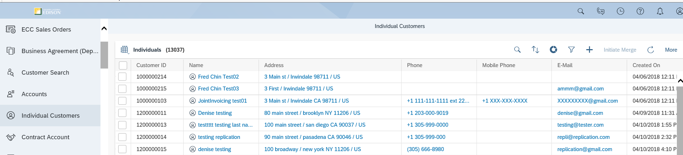
The following data elements will be used by the Business Partner Search (Basic).
Field | Type | Comments
Find | Required | Business Partner Number

Business Partner Search (Advanced)
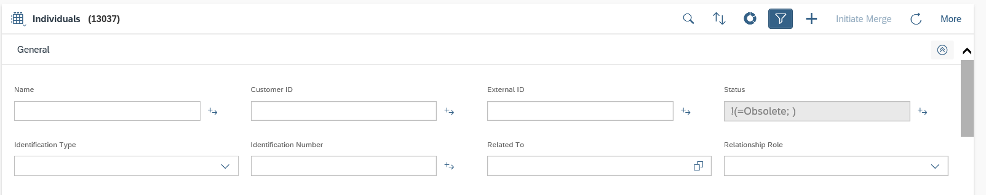
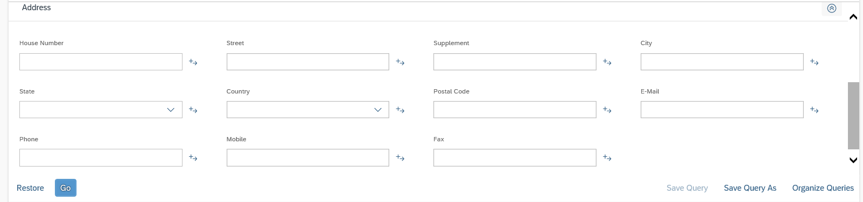
The following data elements will be used by the Business Partner Search (Advanced).
Field | Type | Comments
Customer ID | Optional | Business Partner Number
First Name | Optional | Business Partner’s First Name
Customer ID | Optional | Business Partner Number
Identification Type | Optional | Identification Type (e.g. SSN)
Identification Number | Optional | Identification Number
Related To | Optional | Related to BP Number
Relationship | Optional | Relationship
Phone | Optional | Business Partner’s Phone Number
House Number | Optional | House Number of Business Partner’s Address
Street | Optional | Street of Business Partner’s Address
City | Optional | City of Business Partner’s Address
Apartment Number | Optional | Apartment Number of Business Partner’s Address (House Number Supplement)
Floor | Optional | N/A to SCE
State | Optional | State of Business Partner’s Address
Postal Code | Optional | Postal Code of Business Partner’s Address
Country | Optional | Country of Business Partner’s Address
Email | Optional | Business Partner’s Email Address

Search Contract Account

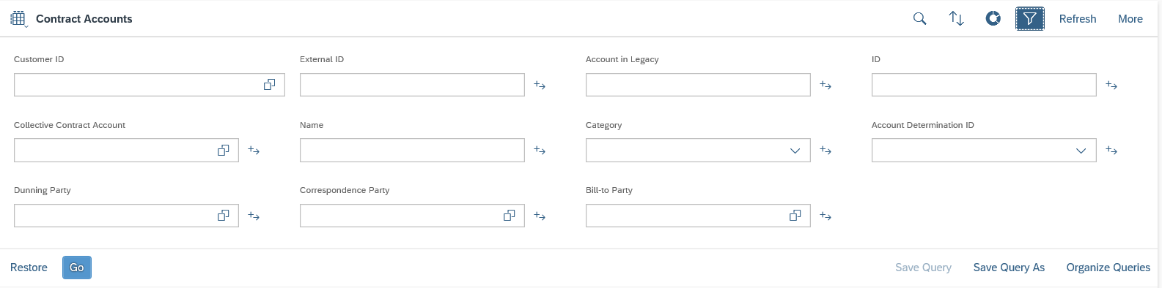
The following data elements will be used by the Contract Account Search.
Field | Type | Comments
Customer ID | Optional | BP number
External ID | Optional | BP number
Account in Legacy | Optional | Legacy Contract Account number
ID | Optional | Contract Account number
Legacy Account | Optional | Legacy Contract Account number
Collective CA | Optional | Collective Contract Account number
Name | Optional | Contract Account name
Category | Optional | Contract Account category
Account Determination ID | Optional | Account Determination ID
Dunning Party | Optional | N/A
Correspondence Party | Optional | N/A
Bill to Party | Optional | N/A

Search Premise
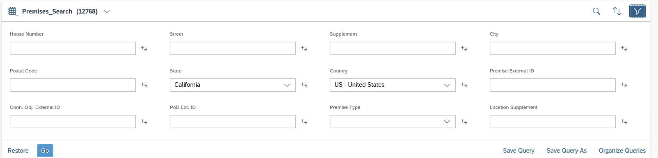
The following data elements will be used by the Premise Advance Search.
Field | Type | Comments
House Number | Optional | House Number of Business Partner’s Address
Street | Optional | Street of Business Partner’s Address
City | Optional | City of Business Partner’s Address
State | Optional | State of Business Partner’s Address
Postal Code | Optional | Postal Code of Business Partner’s Address
Country | Optional | Country of Business Partner’s Address
Premise External ID | Optional | Premise External ID
Conn. Obj. External ID | Optional | Connection Object Number
PoD External ID | Optional | PoD ID Number
Premise Type | Optional | N/A
Location Supplement | Optional | N/A

Billing Overview and Bill Image



The following data elements will be used by the Billing Overview and Bill Image.
Field | Type | Comments
Invoice Number | Display | Invoice Number
Invoice Date | Display | Date invoice was generated
Amount Due | Display | Total amount due for invoice
Due Date | Display | Date invoice is due
Open Amount | Display | Remaining amount of invoice still due
Payments | Display | Payments received towards amount due
Reversed | Display | Check box advising if invoice has been reversed

View E-Bill via FOP or S/4

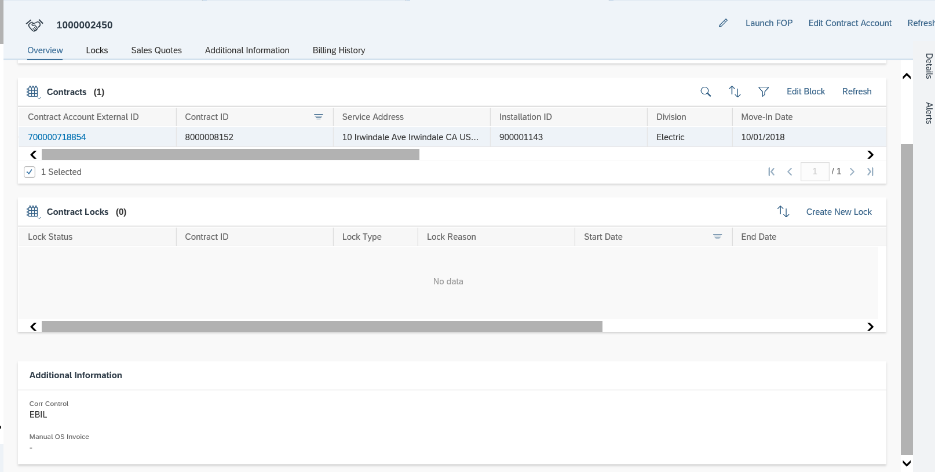
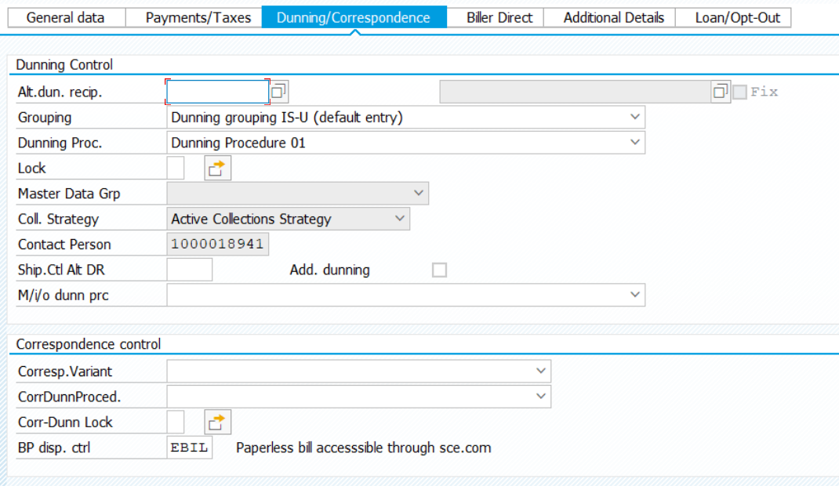
The following data elements will be used by the View E-Bill.
Field | Type | Comments
Send Control GP | Optional | Drop-down list containing E-Bill opt-in

    - Source Systems and Data Volumes
The table below contains the data volumes for bill inquiry received and completed.
Month | BI’s Received  2016 | BI’s Completed  2016 | BI’s Received  2017 | BI’s Completed  2017
January | 1,341 | 735 | 1401 | 1,146
February | 1,246 | 1,736 | 1,218 | 1,333
March | 697 | 936 | 986 | 1,160
April | 360 | 516 | 519 | 515
May | 382 | 374 | 566 | 568
June | 478 | 474 | 655 | 654
July | 744 | 579 | 1,081 | 968
August | 1,337 | 1,238 | 1,632 | 1,581
September | 961 | 1,061 | 1,049 | 1,090
October | 536 | 701 | 904 | 916
November | 436 | 434 | 601 | 613
December | 749 | 718 | 648 | 684
TOTAL | 9,266 | 9502 | 11,260 | 11,228

Cloud for Customer (C4C) Integration

Processes
Bill Inquiries can be handled in Hybris C4C and is available for Front Office agents to display, including search BP, search CA, search Premise, Billing Overview, Bill Image, E-Bill and Service Orders

Hybris C4C Views
- Search BP
- Search CA
- Search Premise
- Billing Overview
- Bill Image
- View E-Bill via FOP
- Service Orders

Activities
An Activity will be created by the CCC or BCD representative manually whenever there is a Bill Inquiry regardless if the bill inquiry is resolved or not. The content that is captured in the Activity long text varies in different Bill Inquiry scenarios. Refer to Customer Interaction BPD Call Disposition Type & Sub Type

Exception Management Requirements
This section outlines a high level description of each BPEM Case or other user workflow items (such as “Tickets” used by Front Office) used to route work requests between business areas. The companion document for this section which outlines the detail of each case is documented in APSE on the Exception Case Template General Document #8.
User Exception Scenario / Description | User Group | Initiated by | Work Distribution
Refer to Exception Case worksheet.

Process Risks and Mitigation
Risk Statement | Mitigation
The option available for rate analysis could be limited due to the features offered by Hybris C4C and GridX. The features of these functionalities are unknown at the moment and SCE is decommissioning of current rate analysis tools. | Utilize worksheet to manually carry out rate analysis.
If a SPOC tool is not available to view MyAccount information and support MyAccount related admin function, there is a risk to need to create more Ticket/BPEM to investigate and resolve customer inquiry. | Increase resources because SCE needs to manually collect the billing and usage information then complete a manual analysis to determine potential recommendation for the customer or identify rebill requirement based on findings.
If the enhancement for billing determinate comparison view is not accepted, the BI team will need to send most inquiry to back office for analysis which will reduce customer satisfaction and increase operation handling and cost. | Increase resources because SCE needs to manually collect the billing and usage information then complete a manual analysis to determine potential recommendation for the customer or identify rebill requirement based on findings.

Key Performance Indicators
The following have been identified as KPI’s at Southern California Edison, along with the means of measuring each KPI and the current measurement statistic for each KPI:
Measured KPI | Description | Measurement Method | Current Statistic
Billing Inquiry resolution | Billing Inquiry needs to be resolved | Report | 92 % within 16 days. 99 % within 28 days. 100 % within 50 days.

Key Metric Definition
The following have been identified as key metrics at Southern California Edison that require business rule for calculation:
Key Metric | Description | Business Rule | Reference
N/A | N/A | N/A | N/A

Controls, Regulatory Rules, and Security
Requirement  ID (from RTM) | “As-Is” Control Requirement | “To Be” Risk Statement | “To-Be” Control Activity” | Control Automation (manual, IT dependent- manual, automated | Relevant technical identifier or RICEFW reference
N/A

Security Considerations
Role | Transaction Code (T-Code) | T-Code Description | Functional Restriction | Organizational Restriction
Bill Inquiry User | Hybris C4C – Billing Overview | Display Invoices, Payments | Display | No
Bill Inquiry User | Hybris C4C – Open Text | Display Bill Images | Display | No
Bill Inquiry User | Hybris C4C – Service Orders | Create, Change, Display Service Orders | Create, Change, Display | No
Bill Inquiry User | Hybris C4C – Contract Account | Create, Change, Display | Create, Change, Display | No
Bill Inquiry User | Hybris C4C - Invoice | Full Reversal | Create | No
Bill Inquiry User | ES21 | Edit Contract | Change | No
Bill Inquiry User | ES22 | Display Contract | Display | No
Bill Inquiry User | ES32 | Display Installation | Display | No
Bill Inquiry User | ES31 | Edit Installation Facts | Edit | No
Bill Inquiry User | CAA2 | Edit Contract Account | Change | No
Bill Inquiry User | CAA3 | Display Contract Account | Display | No
Bill Inquiry User | EEDM02 | Display Interval Data | Display | No
Bill Inquiry User | EA20 | Bill Reversal | Create | No
Bill Inquiry User | /BTR/PP_ASTROLABE | Run BDEx Report | Display | No
Bill Inquiry User | /BTR/PP_SUM | Display BDEx Report | Display | No
Bill Inquiry User | EMMAC2 | View, update, complete, cancel, reassign BPEMs | Edit | No

Custom Program/Transaction Codes
Please identify any custom programs/transaction codes that need to be developed for RICEFW objects.
- Is the custom program executed in the batch mode or dialogue mode
- Is the custom program assigned to an authorization group
- What is the custom transaction code for the custom program
- Should there be an authorization check made against any field in the custom program/custom t-code and if so what is the custom/standard authorization object used(For example does it have to be restricted to residential vs commercial customer)
- Does the custom programs/custom t-codes have any crictial or sensitive customer information that needs extra security

Custom Table | Authorization Grp Assigned | Custom T-code for the Table | Table Access (display/update) | RICEFW Reference ID
Consolidated Billing view | All users | ZCon_Bill_View

Custom Table/Transaction Codes
Please identify any custom tables/transaction codes that need to be developed for RICEFW objects.
- Are there any customer sensitive/critical Z tables created
- What is the authorization group assigned to the table
- Is it just a maintenance or display only table
- What is the Z transaction code for the custom table

Custom Table | Authorization Grp Assigned | Custom T-code for the Table | Table Access (display/update) | RICEFW Reference ID

Data Criticality and Cybersecurity Baseline Risks
Specify the Information this BP will process, receive or transmit; | List data elements from section 2.8 here, including volume.  Data element Description Volume Risk (high , medium, low)
Specify Access Classification /Special Handling or Regulatory Requirement | <Select all that apply>  ☒ PII - Personal Identifiable Information / Privacy Law  ☐ CEII - Critical Energy Infrastructure Information  ☐ FERC SOC (Standards of Conduct)  ☐ NERC CIP Confidential  ☐ Sarbanes-Oxley (SOX) financial reporting data  ☐ SCE utility data accessible by affiliate companies (CPUC)  ☐ PCI - Payment Card Industry Compliance  ☐ Customer Information Service Request (CISR, CISR-DRP)  ☐ Other _<Please Specify>_  ☒ Internal  ☐ Public
Please identify which business Group/Role will require access to the data and/or solution: | <Select all that apply>  ☒ SCE Customer, Res./Comm. Customer;  ☒ SCE OU, Business Function Organization Name: CCC, BCD, Consumer Affairs  ☐ Vendor  ☐ External business partner(s) & SaaS providers  ☐ External on-shore contractors  ☐ External off-shore contractors  ☐ SCE Affiliate Company Employees  ☐ SCE Employees, specify if they have Marketing Function responsibilities (e.g., ES&M)  ☐ SCE contract workers  ☐ Regulatory Agencies  ☐ Others _<Please Specify>_
How many of the SCE Customer, Employee, Vendors will use or affected by the Business Process? | 100; 100 – 1,000; …..
How much Infomration/data would be processed, received or tramitted by the Business Process? | 100; 100 – 1,000; …..
Number of business transactions in average?
Legacy System Module (SAP) the Business Process operated on? | SAP Module, Object name; SCE Enterprise System/Application name: 3rd party application integration;  System Module Operated By:  CSS ….. MSP
Targeted System Module | SAP Module, Object name; SCE Enterprise System/Application name: 3rd party application integration;  System Module Operated By:
Risk Rating  Please see Appendix for guidance on risk ratings (Very Low, Low, Moderate, High, or Very High) based on business impact should a breach occur in any of the three security | Confidential Integration Availaibility  H, M, L H, M, L H, M, L
Additional Security Consideration: | Any Cybersecurity impact in addition to SAP system security:  - Internet Facing Web Application? Yes/No, Detials:  - Internet Facing Application Programming Interface?  - 3rd party Fedrated Authentication & Authorization, Single Sign On?  - Cloud Application (non-C4C)?

Technical Considerations

4.1 RICEF-W Assessment
All of the Forms, Reports, Interfaces, Conversion items, Extensions/Enhancements and Workflows (RICEF-W) that have been identified for this BPD are detailed in the tables below and will represent the totality of all RICEF-W items documented at the time of sign-off of this BPD. Any RICEF-W items that are confirmed via change control after this BPD receives final sign-off, will be managed within Southern California Edison’s APSE environment and not within this document.

Reports
Report Name & Description (List Requirements met by this Report) | Complexity | Reference ID

Interfaces
Interface Name & Description (List Requirements met by this Interface) | Complexity | Reference ID
Ability for user to view rate analysis request and result in GridX | Medium | I-CIM-CS-07 - Interface to GridX for rate analysis request & result
Ability to view historical weather data to assist with resolving Billing Inquiry | Medium | I-CIM-CS-07 - Obtain weather data

Conversion
Conversion Name & Description (List Requirements met by this Conversion) | Complexity | Reference ID

Extension/Enhancements
Extension Name & Description (List Requirements met by this Extension) | Complexity | Reference ID
- Ability for agents to sign up customer contract accounts for e-bills  - Ability for agent to determine which contract accounts are enrolled in e-bill | Medium | E-CIM-CS-07 - Enable eBill & Alt Bill Rec field in Front Office screen
Ability for more than one BP (contact) to receive/enroll in paperless billing (eBill)  (Ability for agent to link 2 or more BP (contact) to one sce.com user id.) | Medium | E-CIM-CS-07 - Alt Bill Rec make available in CA view
User has the ability to enroll a customer in eBill when email is available. | Medium | E-CIM-CS-07 - Auto default account as paperless during Move-In
Ability for user to send eBill confirmation after enrollment. | Medium | E-CIM-CS-07 - Auto send email for eBill enrollment
Ability to compare and present in a consolidated summary view any billed period up to 36 months of history within the customer account. Key elements to be compared:  - Period  - Amount Due  - KWH  - KW  - KVAR  - Usage by Consumption Period (On Peak, Off Peak, etc.)  - Daily average kwh usage  - Period days  - Cost per day | Medium | E-CIM-CS-07 - Bill comparison screen
- Ability to present to the user in a single view the billing/invoice history of the customer  - Ability to present in a summary view the following key elements for billed period in process. Key elements to be viewed:  - Bill Period  - Amount Due  - KWH  - KW  - KVAR  - Usage by Consumption Period (On Peak, Off Peak, etc.)  - Period days  - Daily average kwh usage  - Cost per day | Medium | E-CIM-CS-17 - Consolidated Bill View
System will update the Parent task status when a child task is Completed or Cancelled. If there are multiple Child tasks the Parent task will be updated when ALL Child tasks are Complete / Cancelled | Medium | E-CIM-CS-07 - Establish relationship of a parent and child task
- Ability to capture and view UUT (User Utility Tax) indicator  - Ability to capture UUT exemption and view UUT exemption status | Medium | E-CIM-CS-07 - User Utility Tax indicator and exception status

Forms
Form Name & Description (List Requirements met by this Form) | Complexity | Reference ID
N/A | N/A | N/A

Workflows
Workflow Name & Description (List Requirements met by this Workflow) | Complexity | Reference ID
N/A | N/A | N/A

IDEX Considerations
N/A

Production System Cut-over Considerations
- 12 months of billing history will be migrated over. This will be handled by UB.
- Bill image will not be migrated over, as it is not necessary, they will be available in Open Text
- Bill image generated by OpenText starting 2018 will be made available in CSRP system during cut-over.
- SCE will need IT to extract a list of all active BI related cases prior to go-live so they can be managed outside of SAP until closed or manually created after go-live.

4.4 Other Considerations
N/A

Change Management

5.1 Change Impacts
For the most current change impacts, refer to APSE Gen Doc 914 Change Impact Refresh / Executive Summaries

Change Element Short Description | Change Impact Category | Audience Group(s) | Impact | Business Effort
In SAP, RSO will be able to complete a billing reversal without having to cancel any future dated move in requests. Currently to complete any billing reversals, RSO needs to cancel the turn on request so that they can make billing corrections and then re-issue the turn on request. The time needed to complete the requests can be minimized since the user will not need to re-issue any other orders. | Process (150) | CS-CSOD-RSO All | Low | Low
Front office users will access back office screens using the Front Office Process (FOP) launcher. It is a pending enhancement. The launcher creates an opportunity for users to view data and issue transactions that is not available in the front office UI (eg. installation facts, interval usage, utility tax exemption, joint billing etc.) and minimizes the need for a hand off to the back office. This creates a single sign on to the back office system from the front office. Currently CCC and BCD use one major system for most transactions, CWO and Legacy CRM respectively. Users will need to know when to use the FOP Launcher for transactions and data elements. | Culture Shift;Benefit/Improvement;Process;Decision Making (815) | CS-BCD-All;CS-CP&S-All;CS-CSOD-CCC All;CS-CSOD-Consumer Affairs | High | High
In the front office UI, a ticket must be issued to create a BPEM case to the back office. A BPEM cannot be accessed without issuing the ticket. There will be multiple steps related to creating the request for the case. Currently users issue a basic work request to send a request to the back office. Training will be required on the fields that need to be completed within the ticket and BPEM case to ensure accuracy. | Process (816) | CS-BCD-All;CS-CSOD-CCC All;CS-CSOD-Consumer Affairs, CS-CSOD-RSO All | High | High
The ticket listing functionality creates a flexible view for users that will work on completing ticket requests. Users will have the ability to customize views (eg view all, your own, by customer etc) with multiple search functions and the ability to filter and sort. Reports can be run on tickets by authorized users to review completion rates and due dates to ensure service levels are met. Currently users use email or a queue functionality to view workload especially when it is communication via front office user to front office user. | Benefit/Improvement;Culture Shift;Process (817) | CS-BCD-All;CS-CP&S-All;CS-CSOD-CCC All;CS-CSOD-Consumer Affairs | High | Medium
Users will have the ability to add another BP to receive the bill via the back office. Front office will use the FOP launcher to access the back office to issue the request. This functionality is currently not available in CSS/CWO/Legacy CRM today.  Customer Impact: Customers have the flexibility to request another BP receive a copy of their bill. For instance, parents request copies of bills for their adult children or elderly dependents to assist them with their bills. | Benefit/Improvement;Decision Making;Process (818) | CS-BCD-All;CS-CP&S-All;CS-CSOD-CCC All;CS-CSOD-Consumer Affairs;CS-CSOD-RSO All | Medium | Medium
Billing Inquiry (BI) tool functionality will not be available in front office. Weather data and appliance mix calculation will not be available in SAP. New processes or job aids will need to be created to assist users with completing billing inquiries.  Customer Impact: Indirect impact to customers. It may increase the amount of billing inquiries that need to go to level 2 causing a longer turn around time for customers instead of first call resolution. | Culture Shift;Decision Making;Process (819) | CS-CSOD-CCC All;CS-CSOD-Consumer Affairs, CS-CSOD-RSO All | High | High
Business Customer Division (BCD) Account Managers will have the ability to enroll/de-enroll some customers to e-bill without a hand off to BCD sce.com COE. Large corporations may still need to follow the current process to validate corporate structures. Currently all enrollments are sent to a specialized group in BCD (sce.com COE). As a result, we achieve first call resolution, however, Account Managers will need to complete the end to end process. | Benefit/Improvement; Process; Job Roles (290) | CS-BCD-All | Medium | Medium
Business Customer Division (BCD) will have the ability to create a BPEM via a ticket to different departments for multiple requests such as delayed billing, Direct Install requests etc. Currently requests are centralized and sent to COE for review and then sent to other organizations. SAP process minimizes hand offs and provides a faster resolution for the customer with minimal processing time. | Process; Job Roles; Benefit/Improvement (300) | CS-BCD-All, CS-CSOD-RSO All | Medium | Medium
Billing Inquiry may not have a listing view that is easily accessible for certain information that will assist the CCC with bill questions, such as daily average and KW demand. May have to drill down or click to another screen to find the information - requirements have been added for a list view screen. Enhancement is pending. | Decision Making; Process (363) | CS-CSOD-CCC All; CS-BCD-All; CS-CSOD-Consumer Affairs | Medium | Medium
Payment transfer from 1 account to another will take 2 steps in SAP. The agent will need to move the payment from one account to a clarification work list and then move from the work list to another account. Current process is one step based on selecting the payment. This can add more processing time for the agents that will need to move payments. | Decision Making; Process | CS-CSOD-CCC All | Low | Medium
Front office users will not have visibility to BPEMs that are created in the back office or the status of BPEMs that they create via C4C. Currently users have visibility to all basic work requests issued in CSS/CWO. For some teams, a workaround will be to use BDEX to view BPEM info (e.g., BI team) and they can review notes (Activity Records and BP Contact records) in C4C to view the full picture of the account. | Process, Decision (827) | CCC, GC Services, BCD, Consumer Affairs, CP&S | High | High
The BI team will need to use three systems to receive, view and complete their work including C4C, S/4 Hana and BDEX. Today, the BI Team manages their work in CSS and an ACCESS DB. There will be additional steps needed to ensure that they get the full picture of the account including any pending events (eg BPEM cases, service order, rebills etc), notes and usage data. | Process (828) | CS-CSOD-CCC-BI | Med | Med
Users will not be able to view any change logs on tickets. The view will only be based on the last user that worked on the ticket. Users will not be able to view who made changes to the ticket request or what updates were made to the tickets. This can be an issue when researching the account for escalations. Currently users have a view log that shows changes made to requests in CSS/CWO. | Decision Making;Process;Regulatory/Legal (844) | CS-BCD-All;CS-CP&S-All;CS-CSOD-CCC All;CS-CSOD-Consumer Affairs;CS-CSOD-RSO All | Medium | Medium

Below is a description of each:
Change Element Short Description: Describes the ‘As-Is’ scenario and what is changing.
Change Impact Category: Determined by asking the questions below.
- Staffing Levels - Is the work effort increasing or decreasing (staffing levels), and how (e.g., task automation, new process/tasks)?
- Job Roles - Will the responsibilities, authority, or required skills for a job or job roles change? Will people be reporting to new leaders? Will managers’ responsibilities change?
- Compensation / Performance - Will the changes have such an impact on roles of an individual that merits a change in how they are compensated or how their performance will be evaluated? What behaviors are rewarded and recognized?
- Organization Structure - Is the ownership of the Process or Data changing (think departments, jobs, or roles, not individuals)?
- Decision Making - Will any of the changes impact how decisions are made, by or between, business units / departments? Who makes them, how they determine the criteria for making a change?
- Culture Shift - Will organizational value systems impact the way change happens or be impacted by the change? What are the underlying values of the organization that will directly influence the way change will be accepted and how much work will ultimately be required to ensure successful outcomes for the business?
- Location / Facilities - Will the change impact the physical location where they process is being implemented or require changes to the facilities to enable the process to be effective?
- Process - Any change to the current process (e.g. manual process becomes automatic, or vice versa)? Are there new processes being introduced or an old process being decommissioned? Is there a requirement to change an existing business rule or business policy? Will new business rule or policy needs to be introduced and enforced or complied to?
- Regulatory/ Legal - Are there any legal / regulatory requirements that might be impacted
- Technology - Are other applications impacted (e.g., going away, becoming read-only), or are there new requirements (e.g., new SW / HW, new version)
- Benefit/Improvement - Will there be an improvement or benefit to any of the stakeholders because of this change. (Be sure to include any pain points that are being alleviated)
- Other - Are there emotional implications stemming from any of these changes (think of buy-in issues or fears)
Audience Group(s): These are the affected departments, divisions etc…
Impact: The following were used to determine the impact:

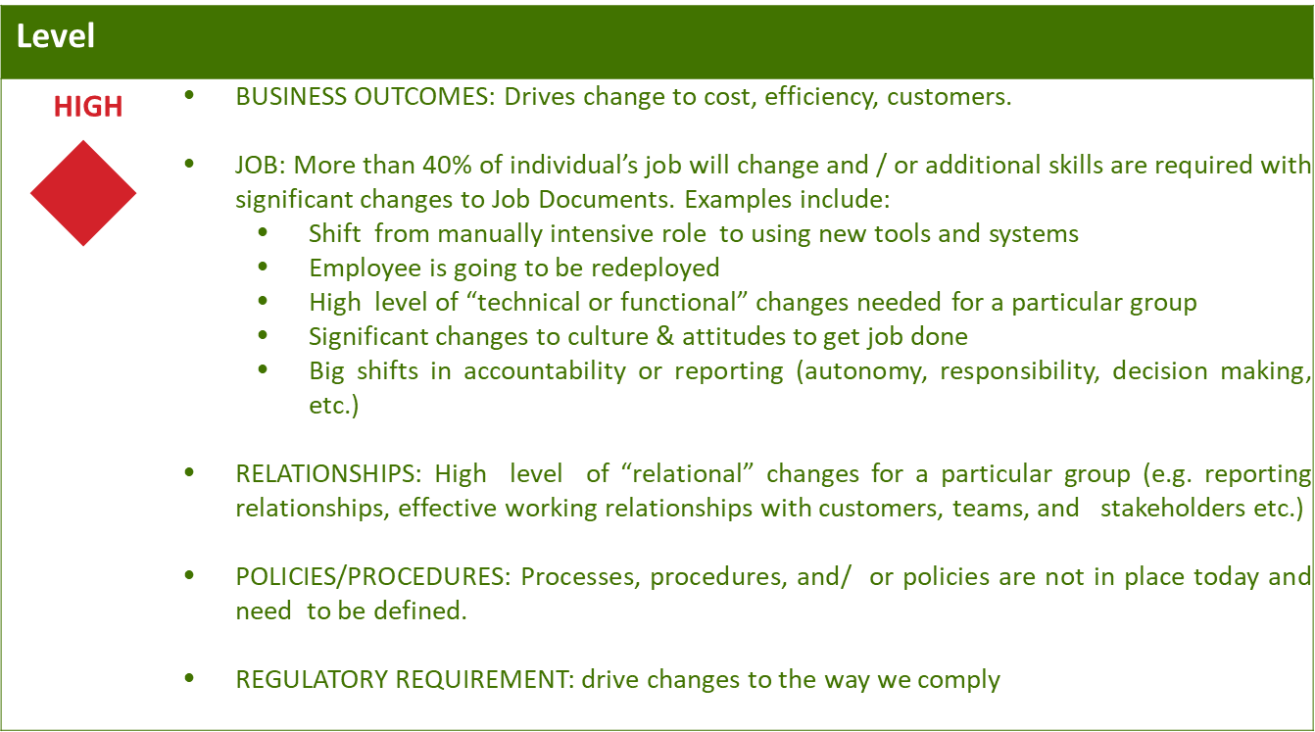
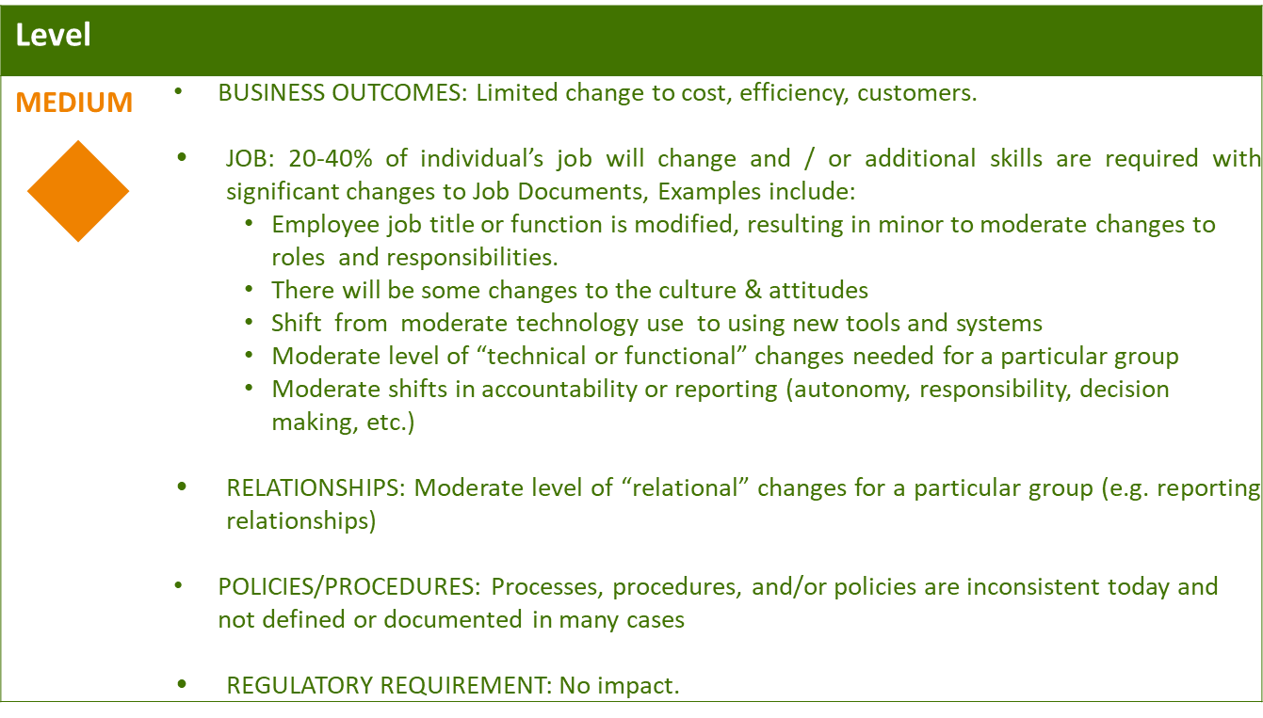
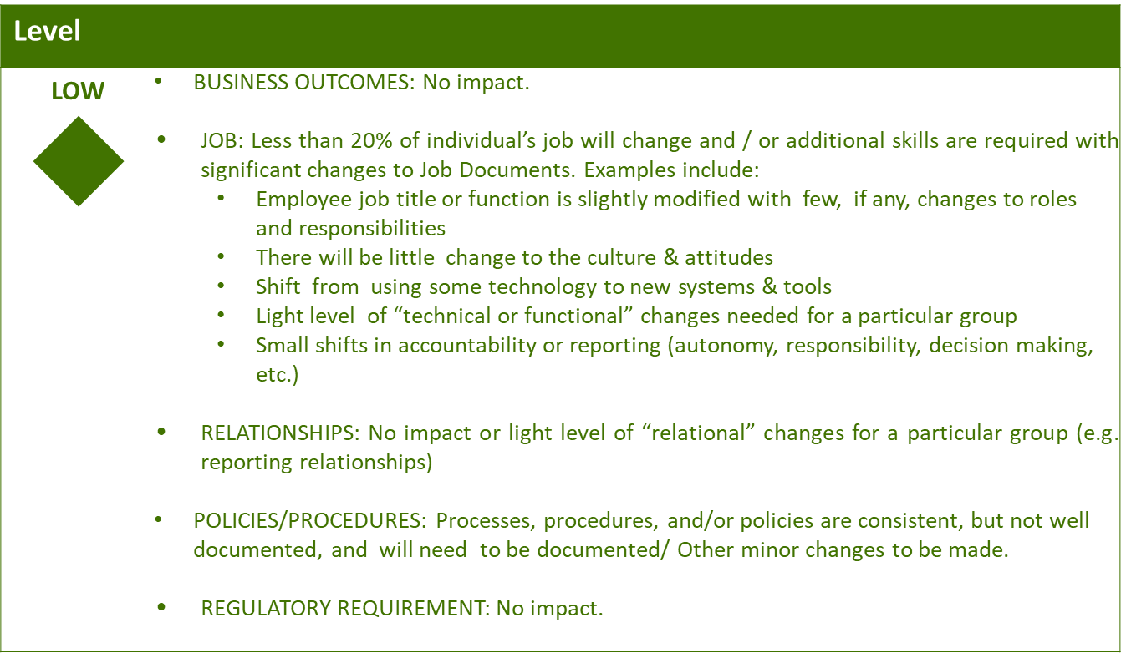

Business Effort: Initial assessment of the impact to the business High, Medium, Low

Requirements
Requirement # | APSE Requirement # | Requirement Description

Tickets
The attached document contains the list of Tickets that identified in this BPD.

8. Appendix

